|  |
| --- |
| Faculty of Applied Sciences and Technology |
| **J2EE web application:ABC Protection Plan** |
| ITE5332 - Project |
|  |
| **Kien Tran, Chi Bui** |
| **11/16/19** |

|  |
| --- |
| This is the ITE5322 Project which students design a web application using J2EE/JSP/JSTL |

Table of Contents

Section 1 : Analysis 2

Section 2: Database Design 3

Section 3 : Design Webforms 4

Section 4 : JSP/JSTL codings 5

Section 5 : New functionality 6

Section 6: Program execution/output 7

Section 7: How to Deploy the Web application 8

Section 8: Project Feedback 9

# Section 1 : Analysis

(Describe how you plan to solve the problem including steps that you take in this project and how you divide the work in your group.

Prepare/add all related Software Analysis/Design documents)

# Section 2: Database Design

(Describe the major considerations in designing the Database. Add Database/Table structure/relations using standard diagrams/tools here)

# Section 3 : UI Design (Webforms)

(Show all the webforms and the layout of each webform. Also indicate which table(s) interact with that webform, the validation rules behind each form, and the interconnection between forms )

# Section 4 : JSP/JSTL codings

(Describe each JSP pages that you design including the file-name, the main functionalities of each JSP page. Explain (1) Error Handling (2) Manage CRUD operations (3) Control Login/Access level – *Don’t copy/paste the whole coding here*, *just the simple explanation of main building block in each JSP file*)

# Section 5 : New functionality

(Describe the new functionality that you have added to the web application. How did you come up with the idea, and how did you implement it)

We add the authorization function to the web beside authentication. This function is to make sure that an authenticated user can only access certain resources which granted to the role that user belonging to. For example, normal users are not allowed to access the resources that granted to admin user.

We came up with this idea because we believe that for every application, the security in general or authorization in specific is very important aspect that need to be fulfilled in order to protect information.

We implemented a center authorization function that will be injected in to all resources of the system. When an authenticated user accesses a resource, the authorization function will check whether the role of current user is granted the permission to access that resource or not. If it is not the case, user will be redirect to a specific page.

# Section 6: Program execution/output

(Show how program works -- add some screenshots, from two aspects, ADMIN login, CUSTOMER login )

1. New user register an account

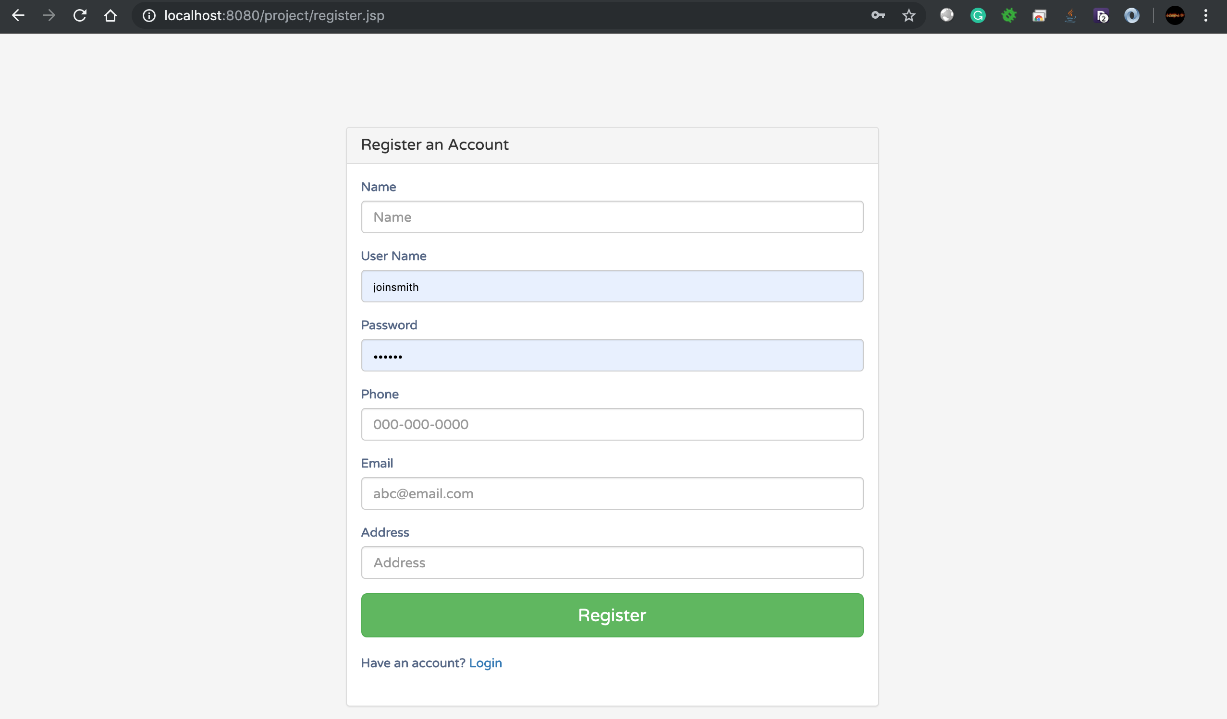

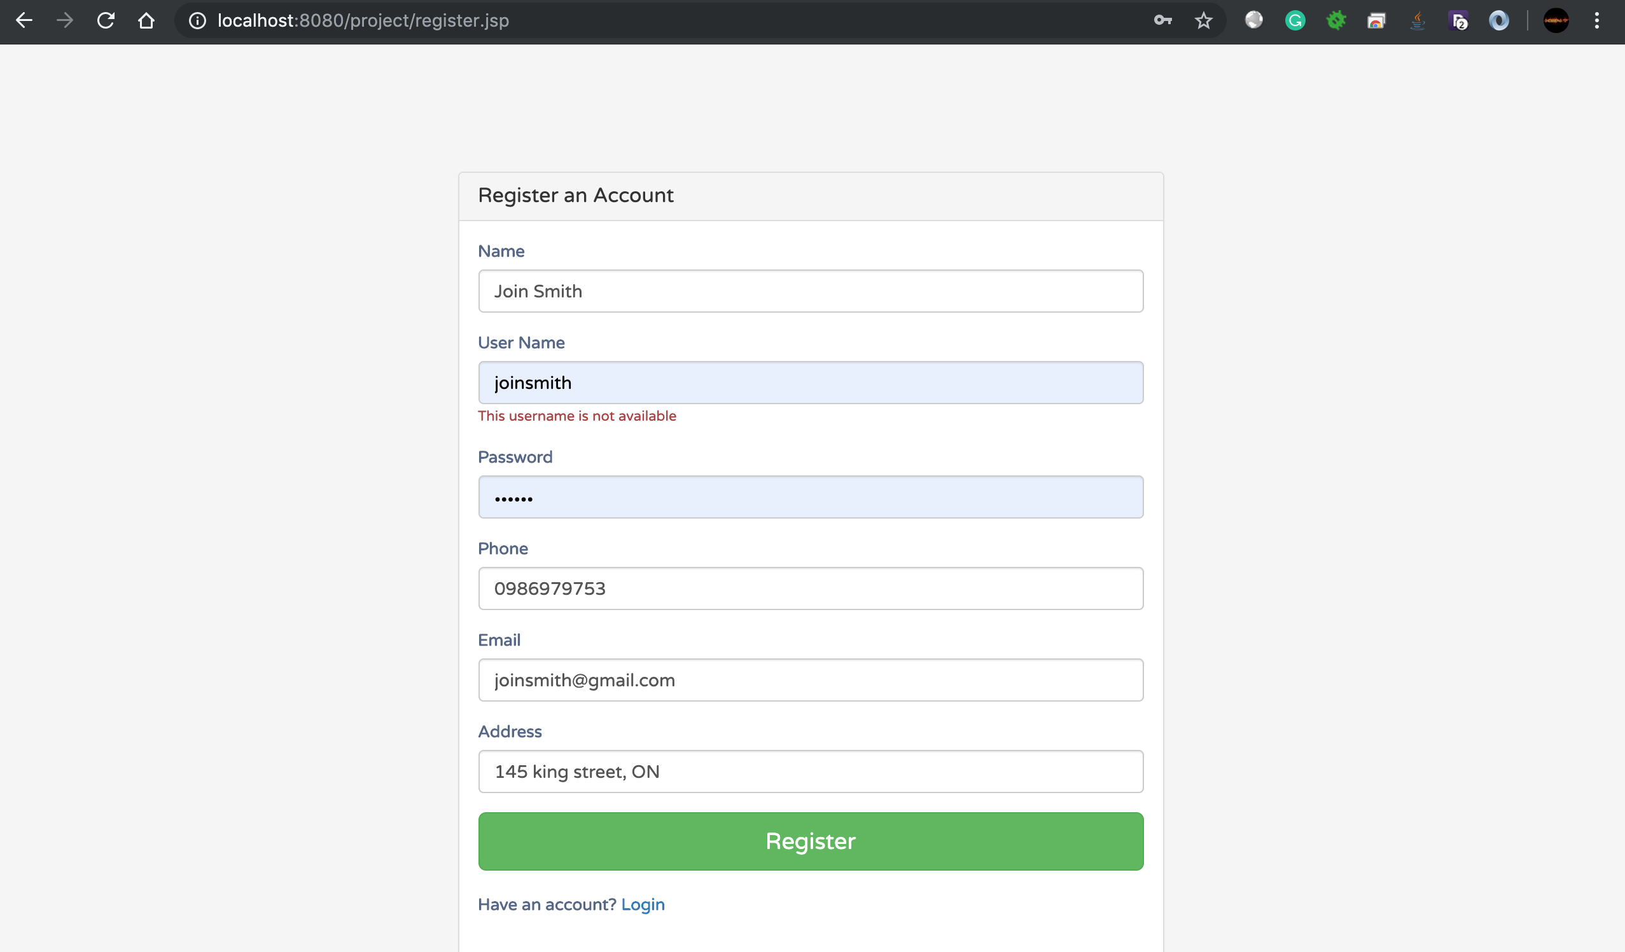

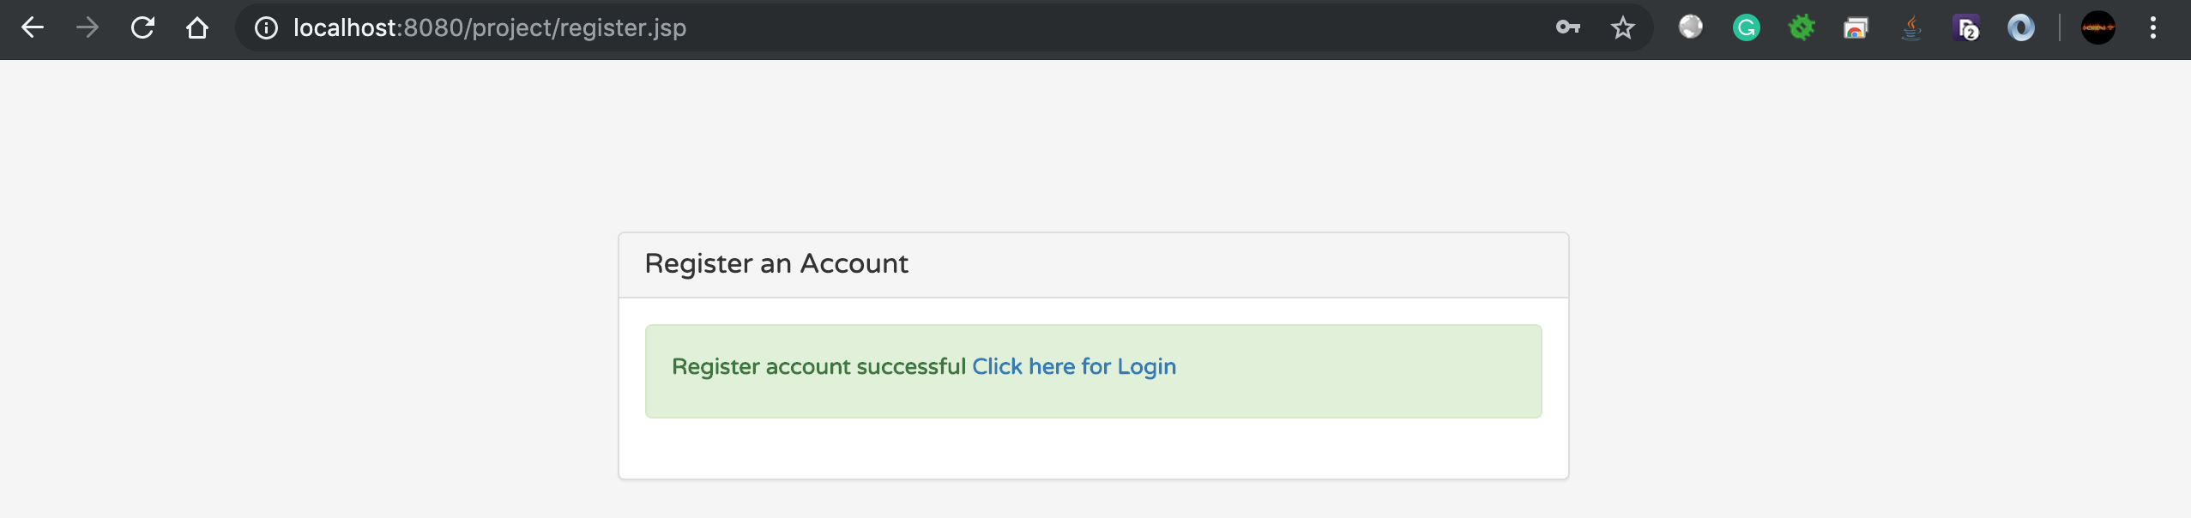

1. User login

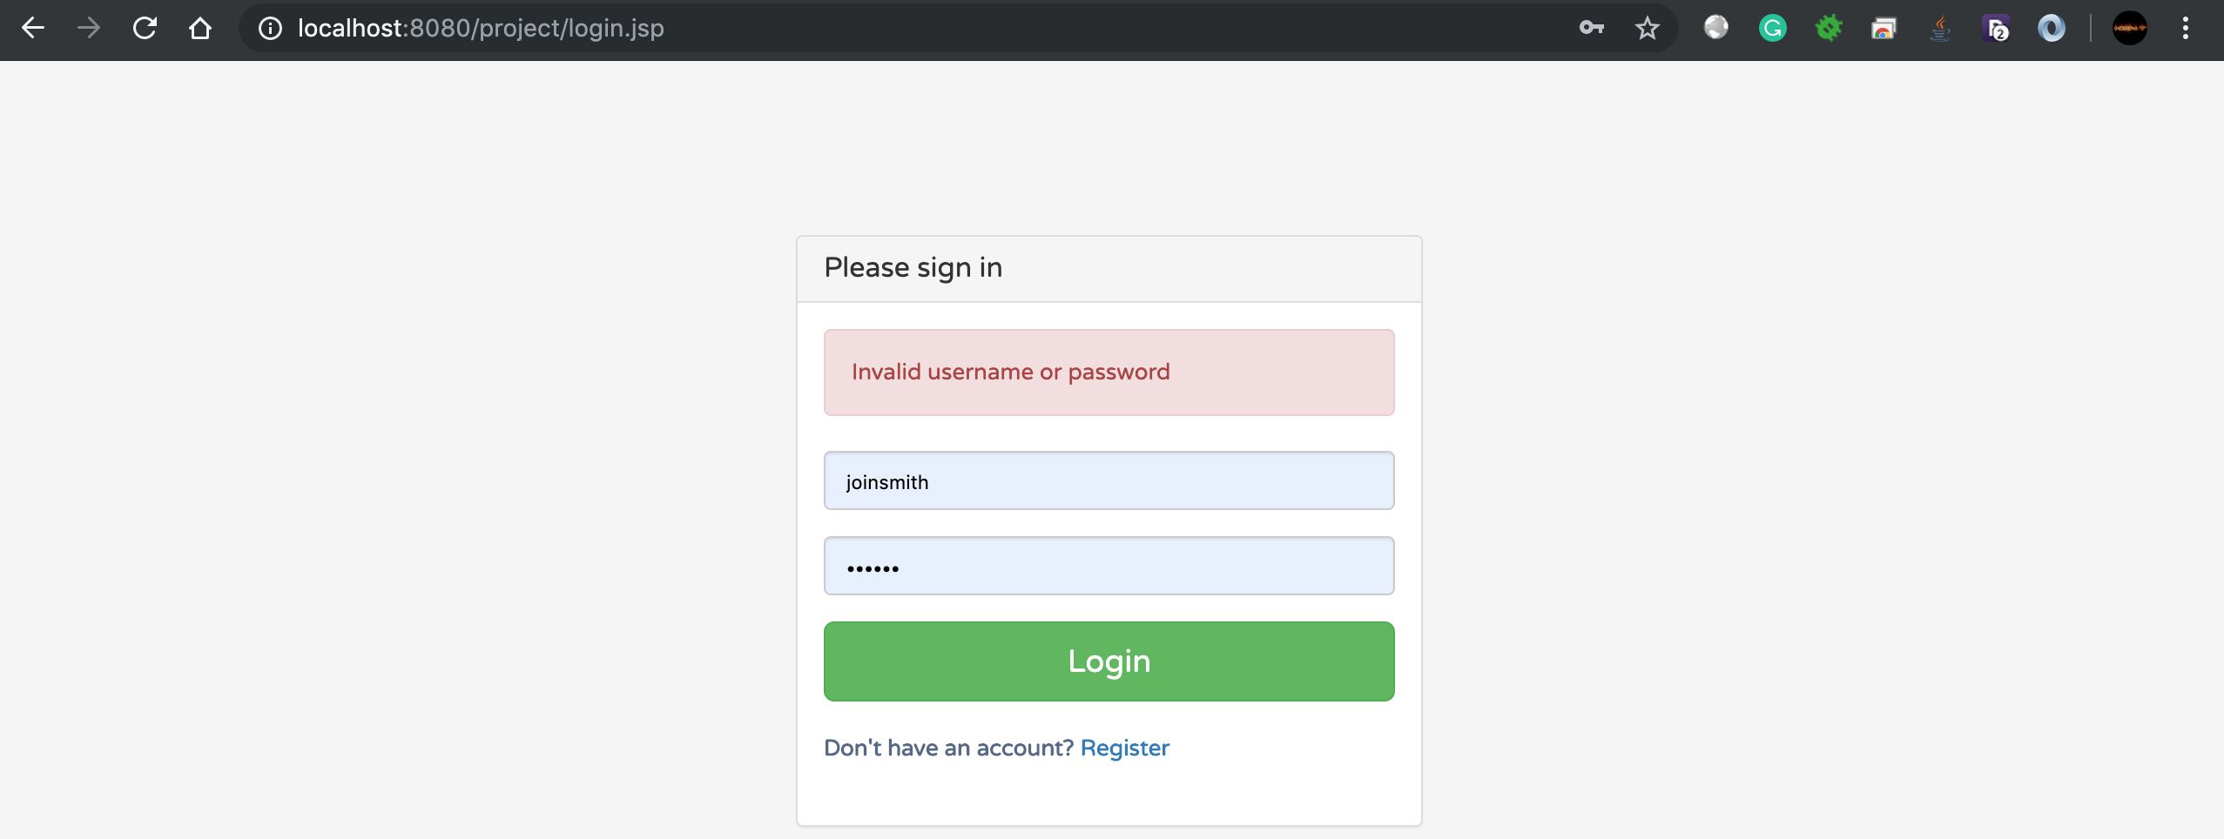

1. Home page of client view which list all registered products of that user. User can search and registered new product

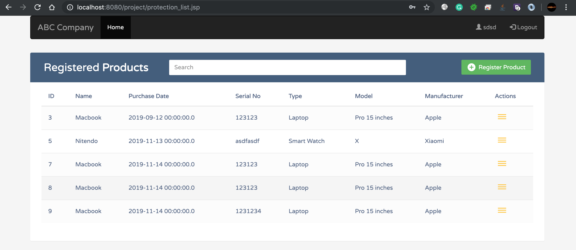

1. User register new product for protection

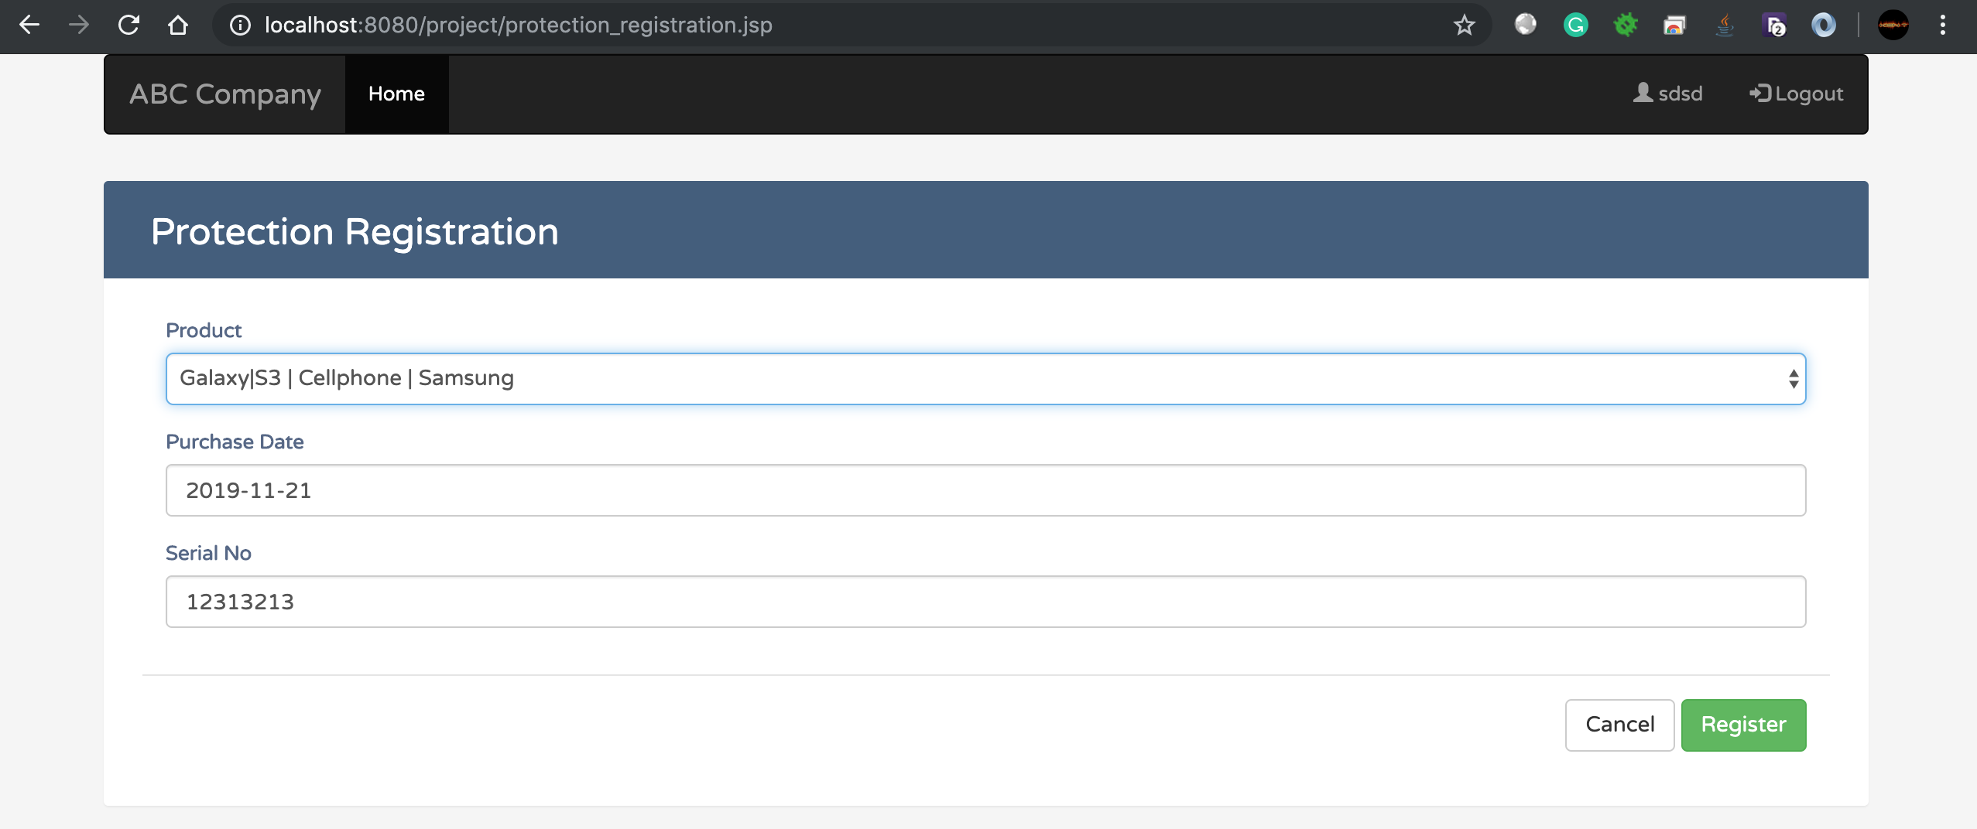

1. Product register successful message

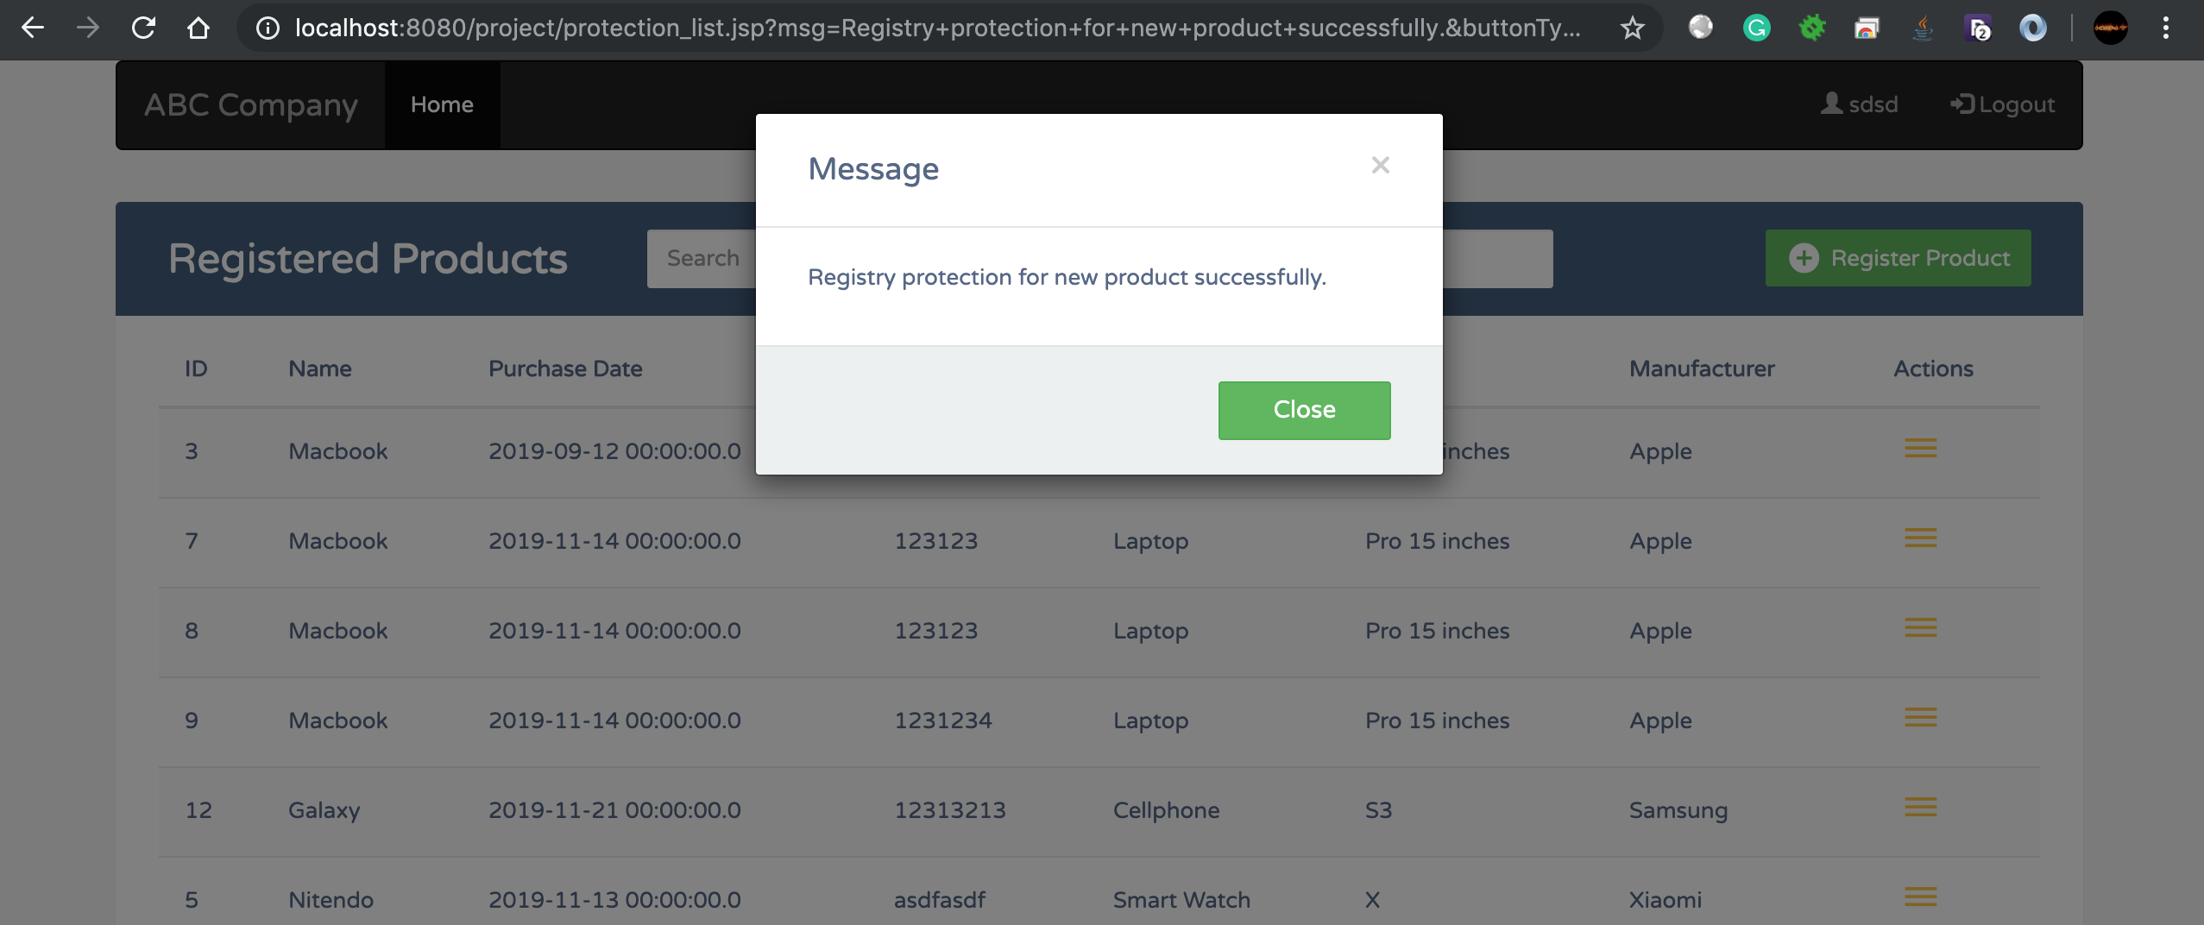

1. When user click on the icon on the left side of each product in the list. User will be navigated to Protection Claims list of that product. In this page, user can view, search all claims or add a new claim for this product

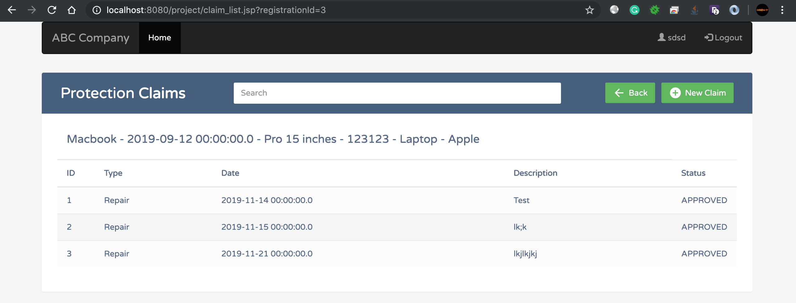

1. User can only claim maximum 3 times within 5 years since purchase date for each product.

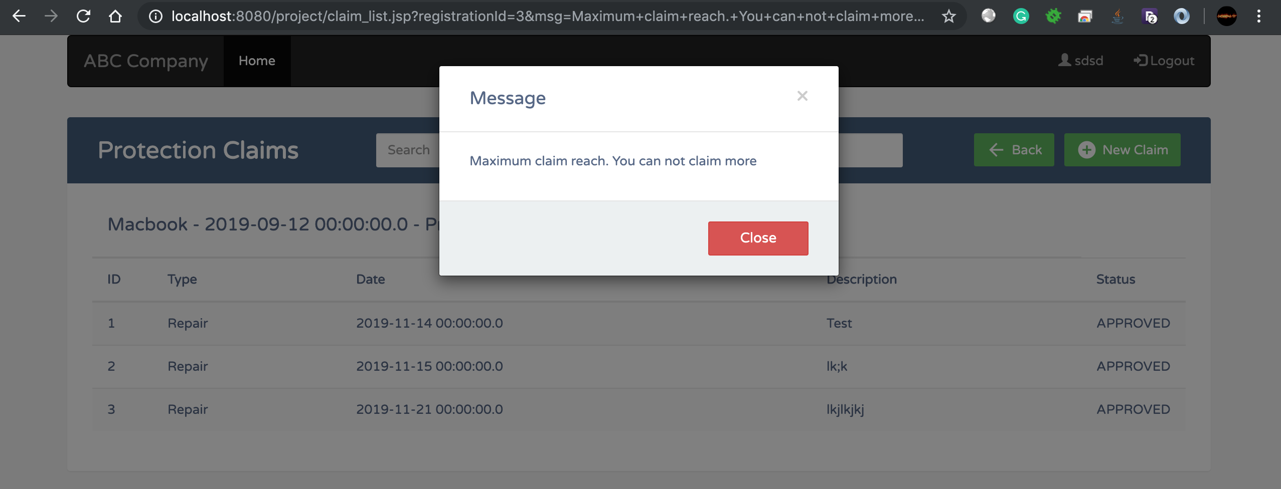

1. User can add a new claim for a product

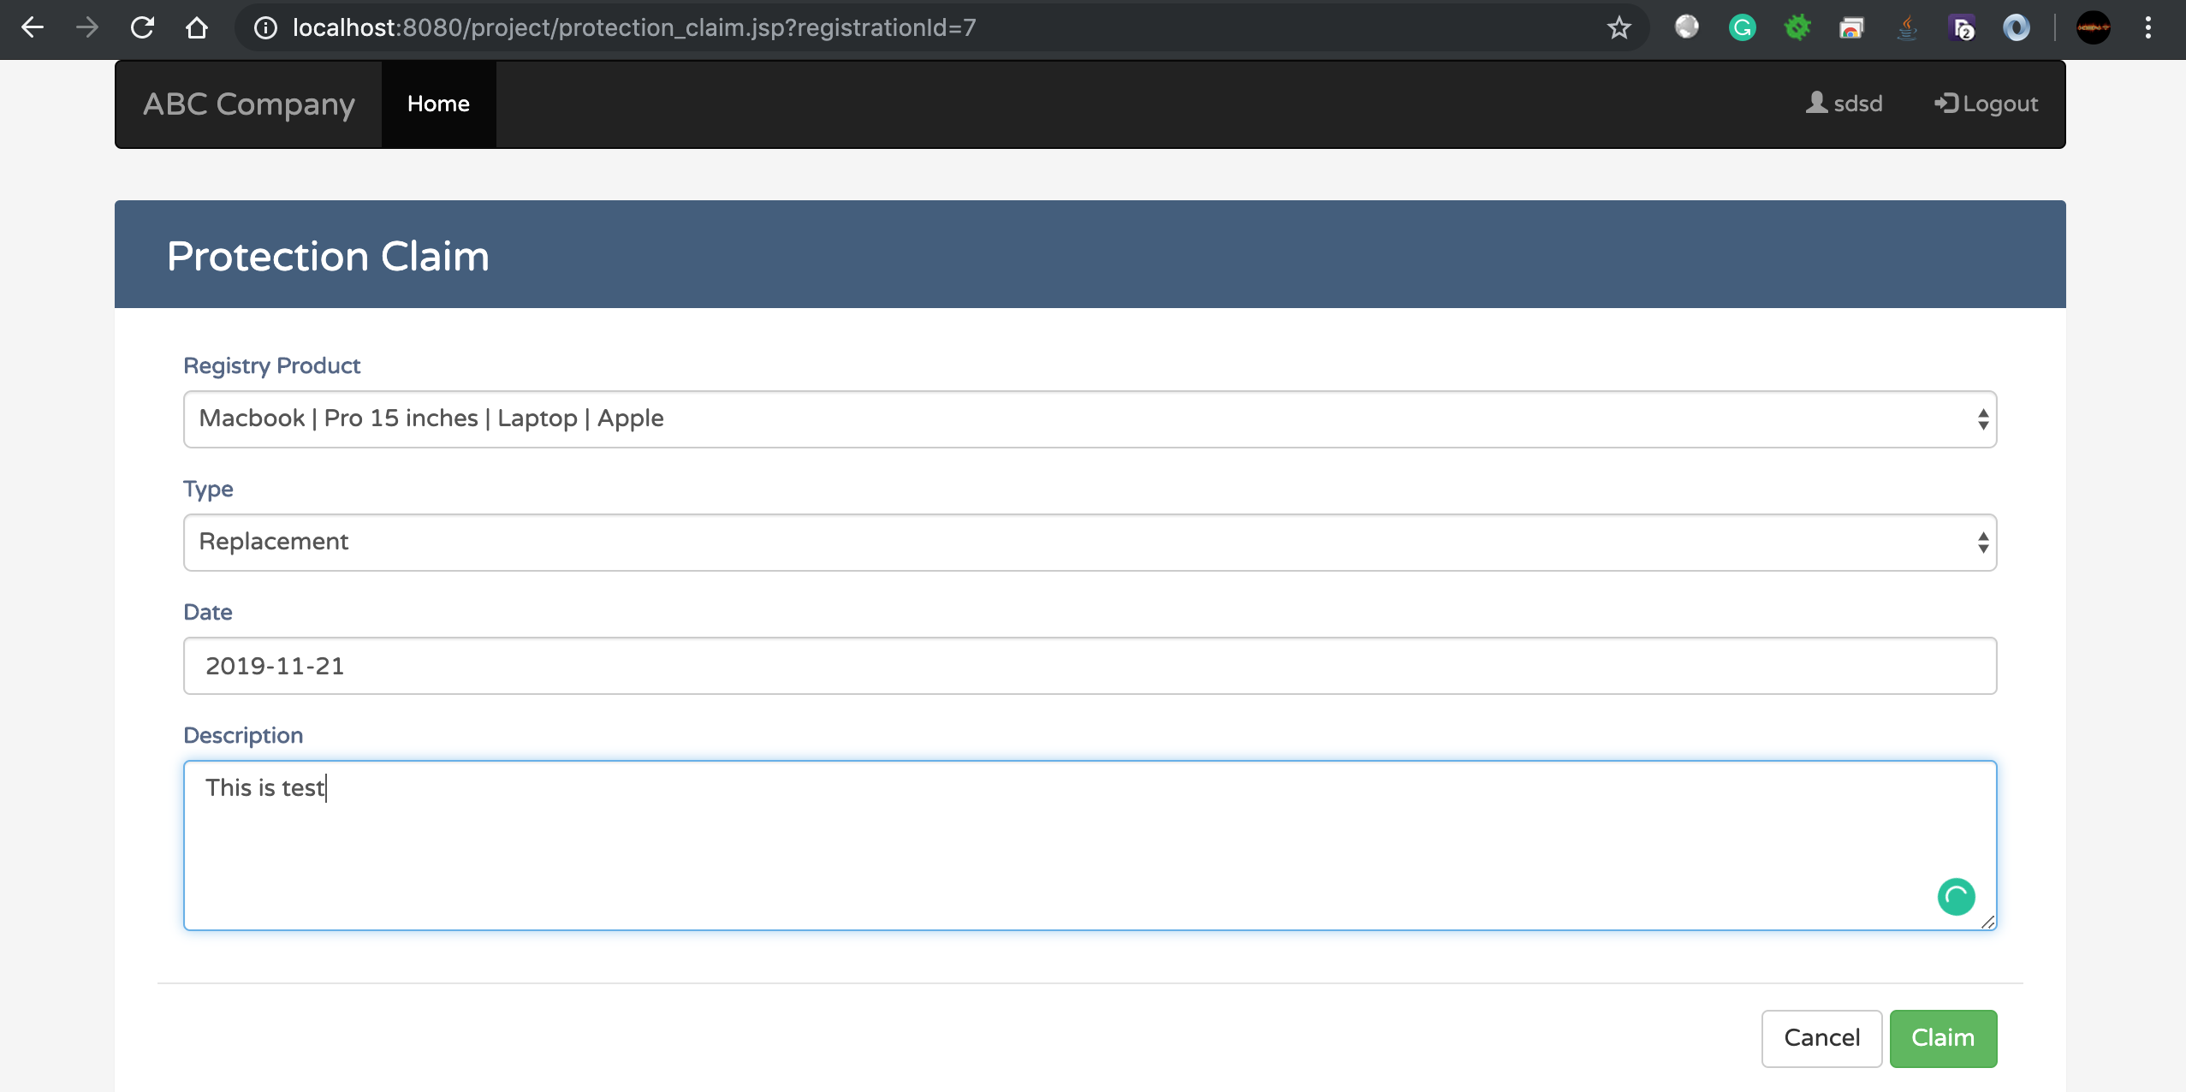

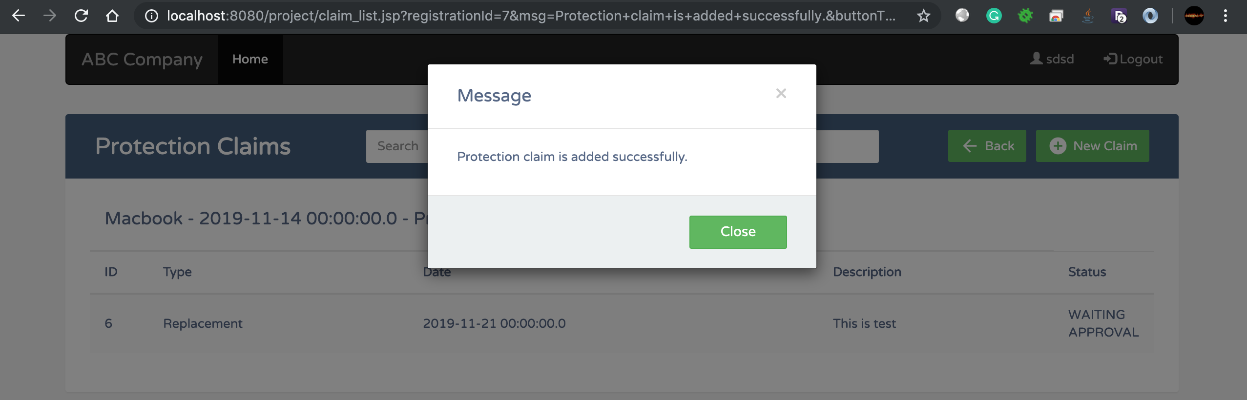

1. Admin login

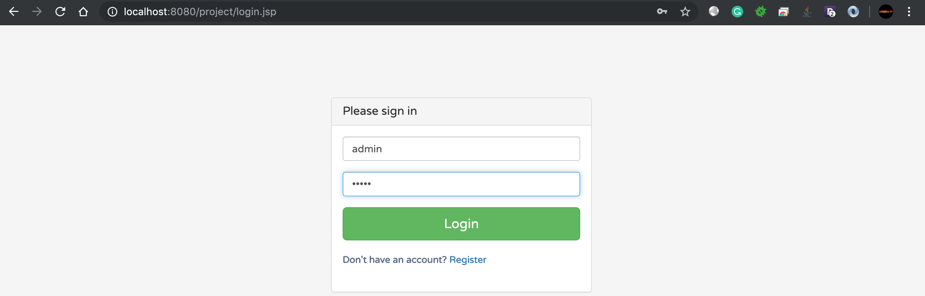

1. Home page of admin will list all claim from users that are waiting for approval

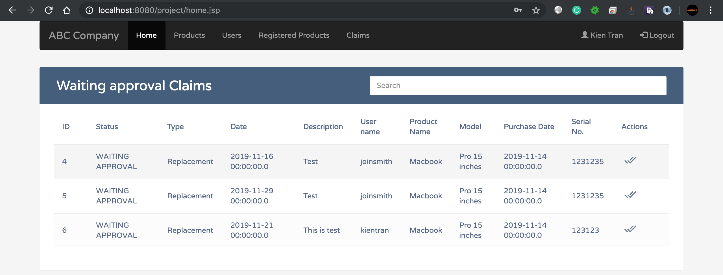

1. Admin can approve for a claim

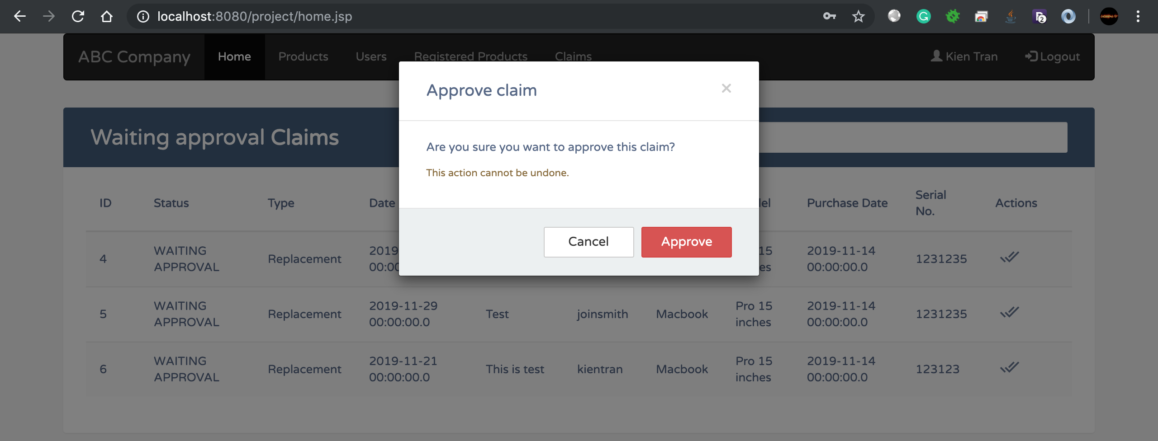

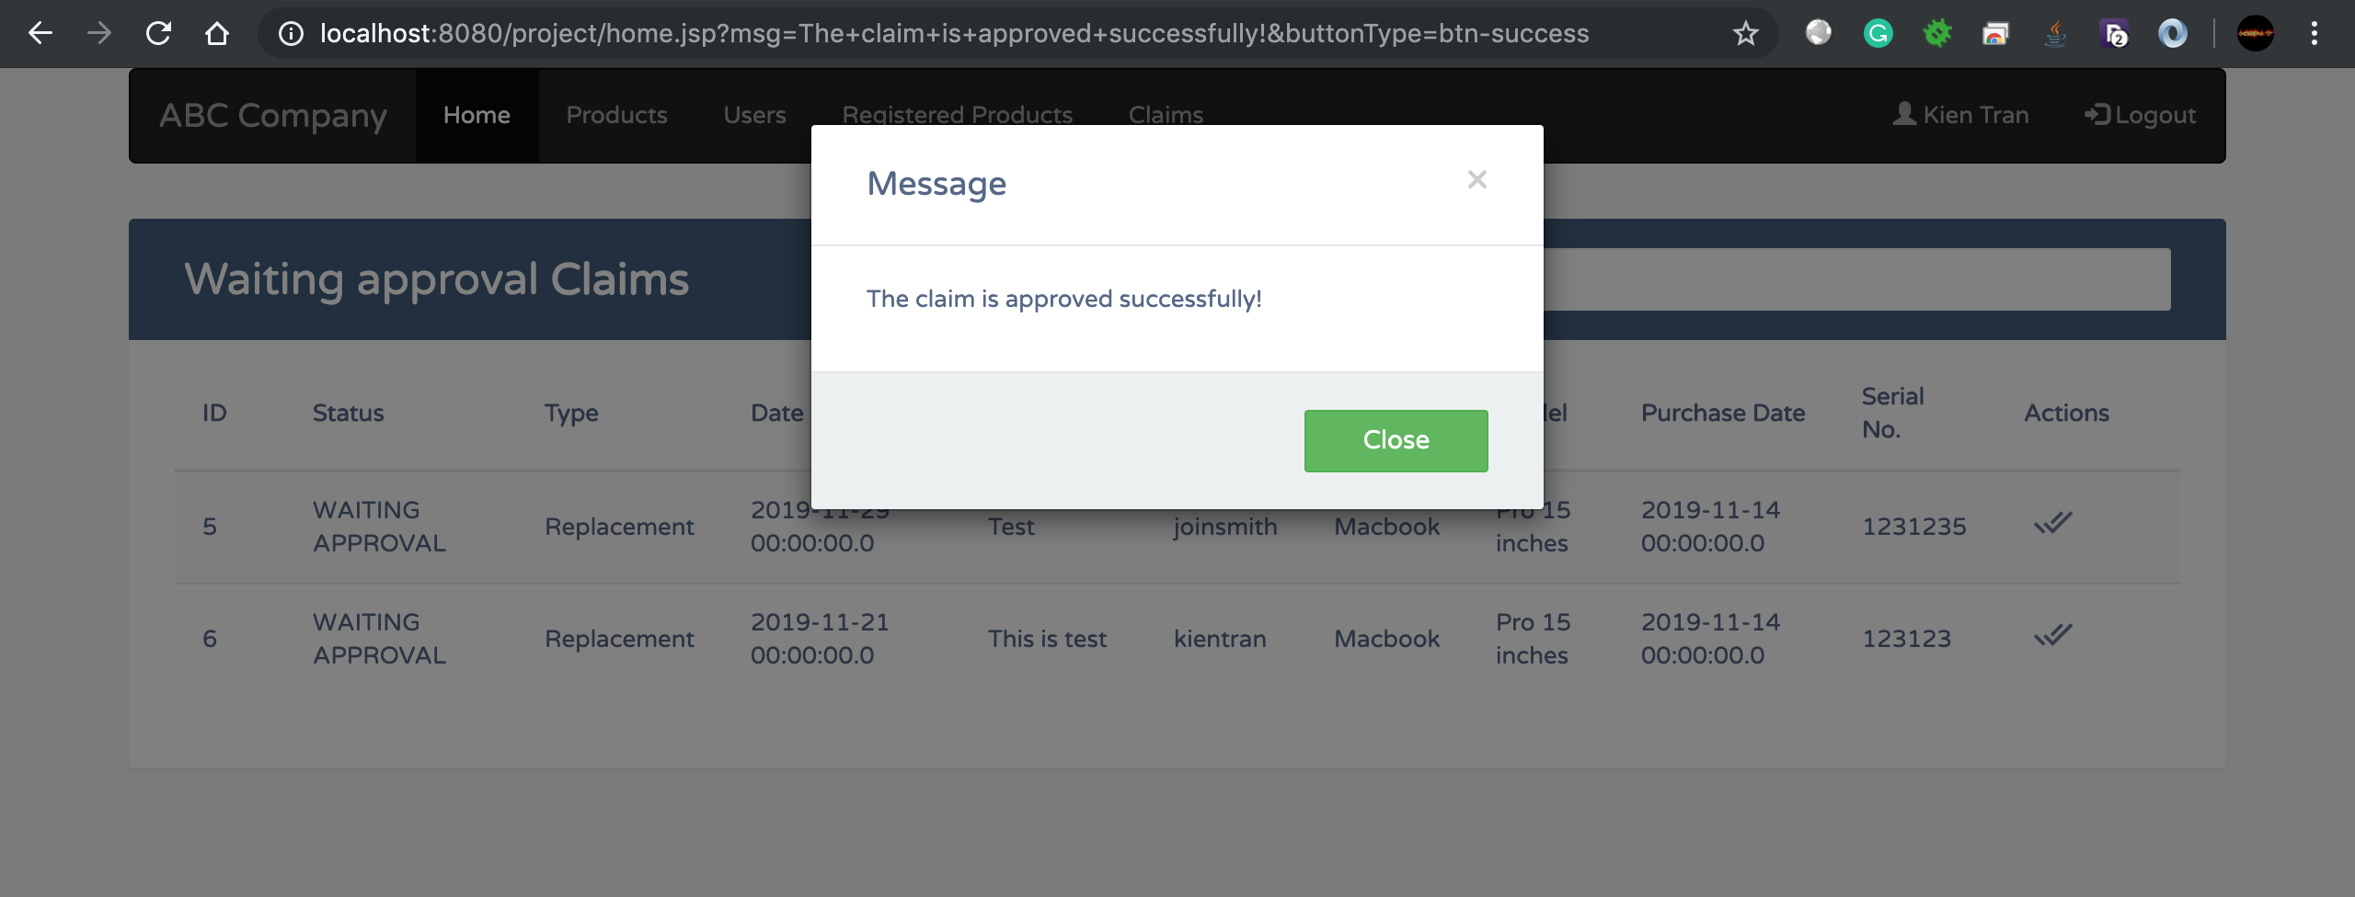

1. Product Management page list all products in the system, admin can search, add, edit or delete the product

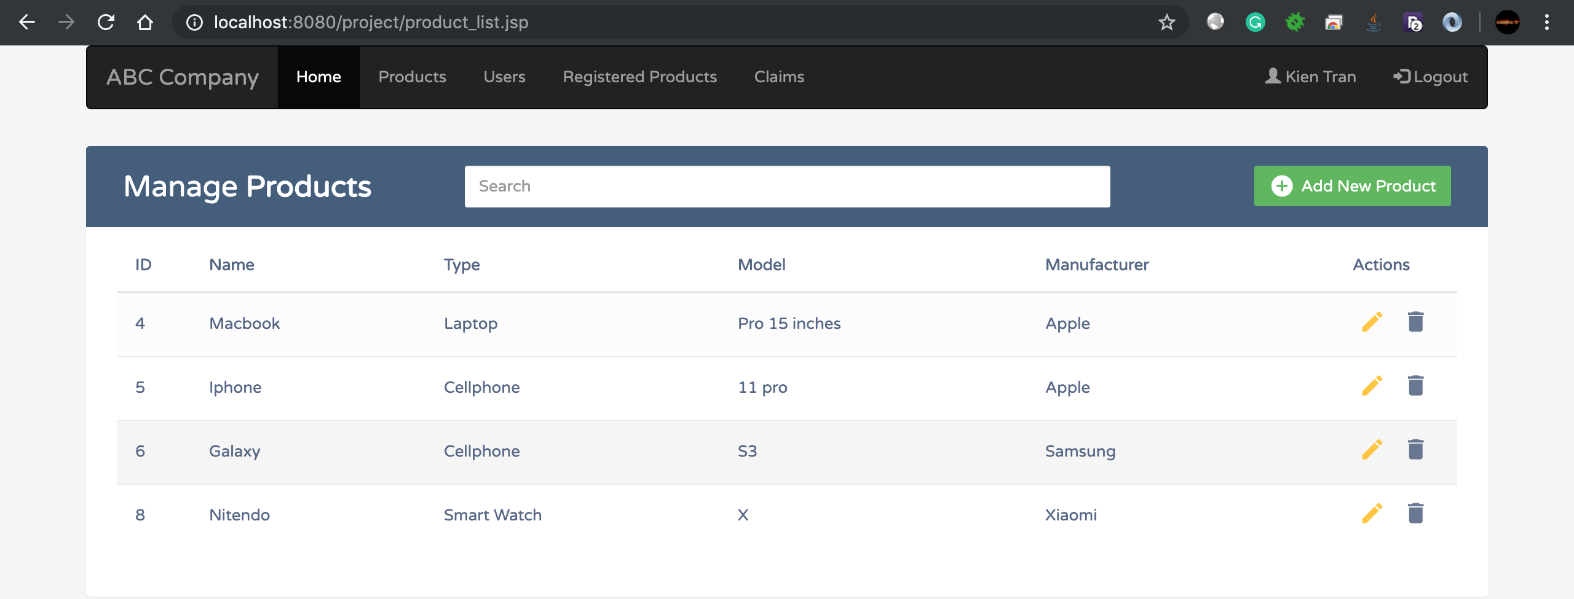

1. Searching a product

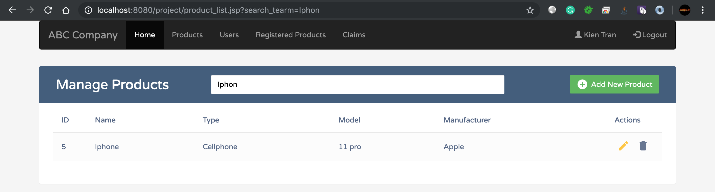

1. Adding a product

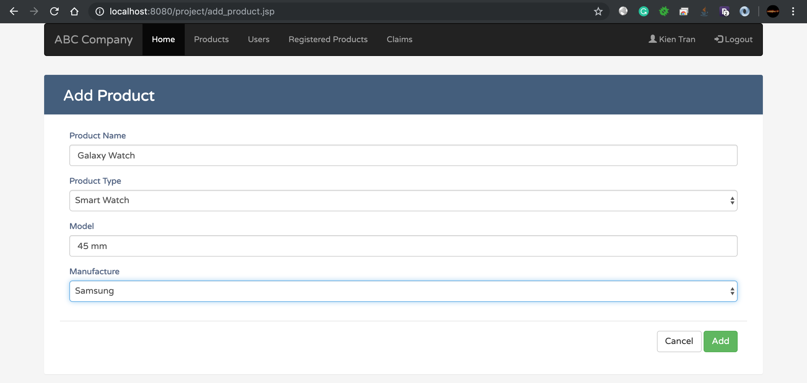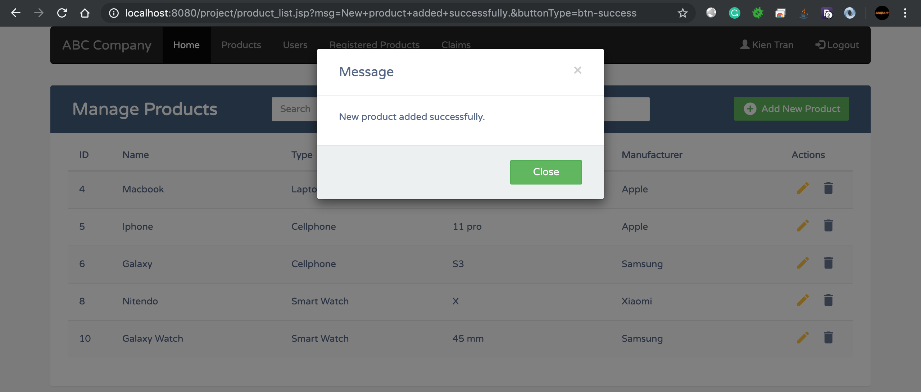

1. Updating a product

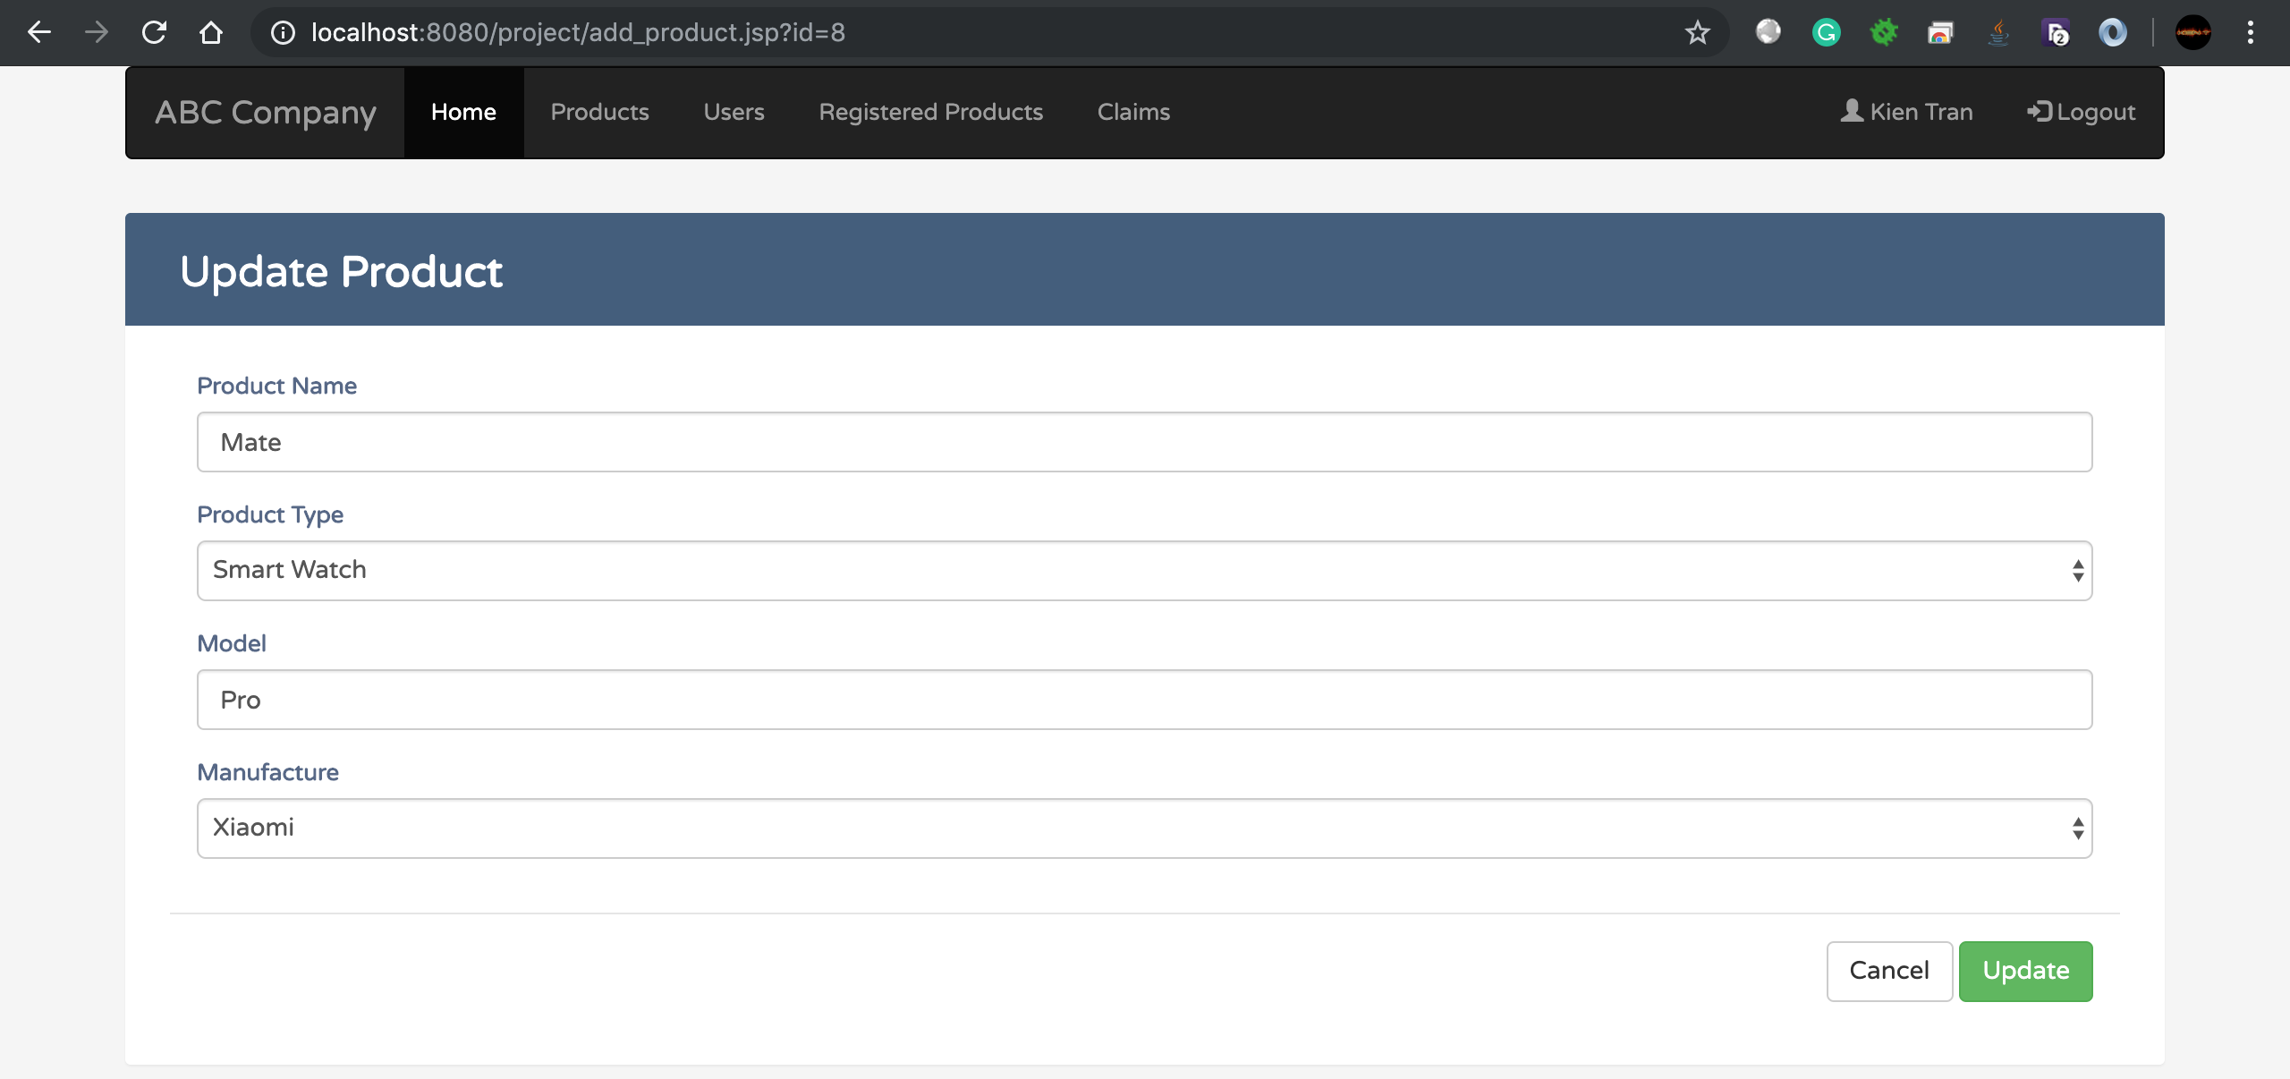

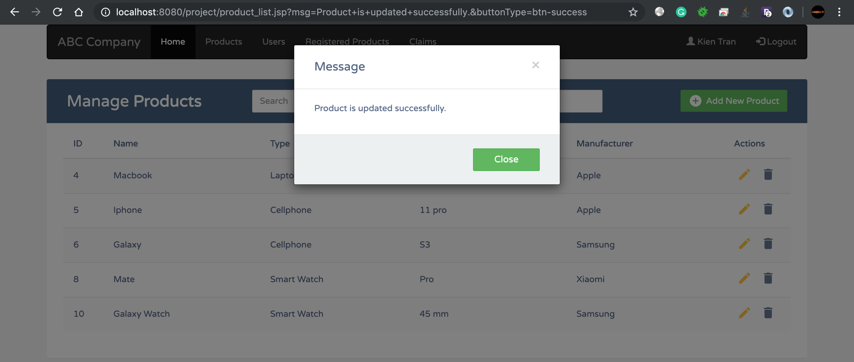

1. Deleting a product

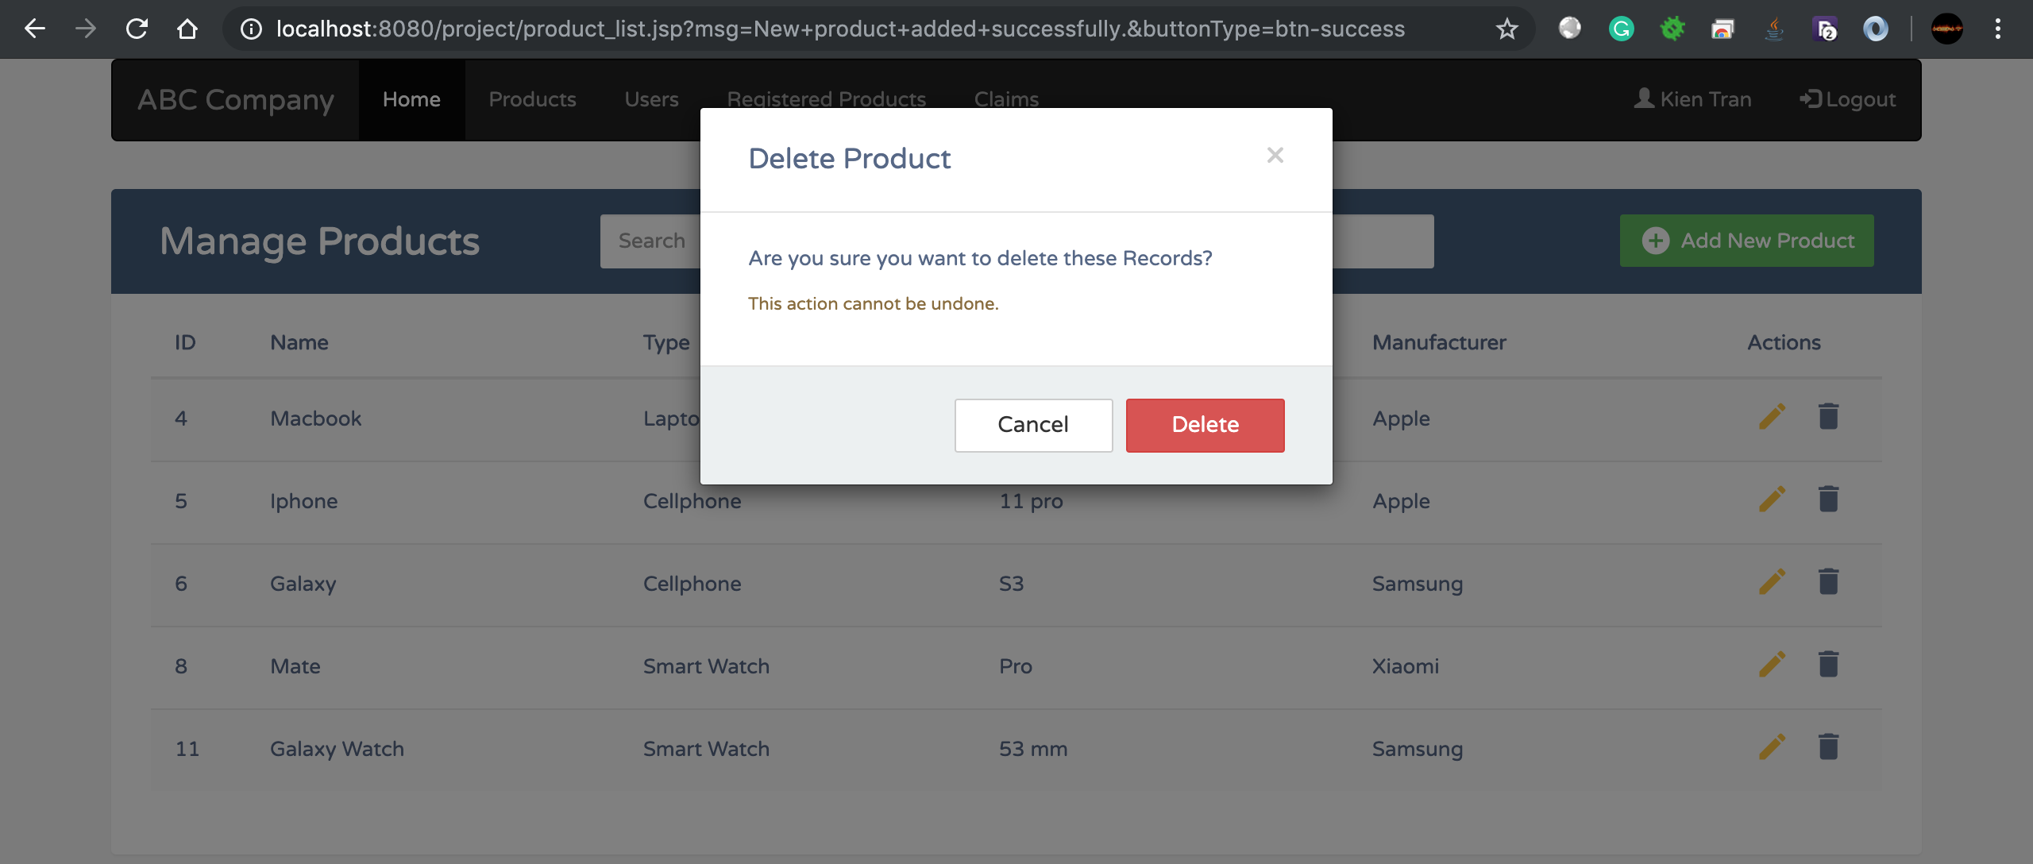

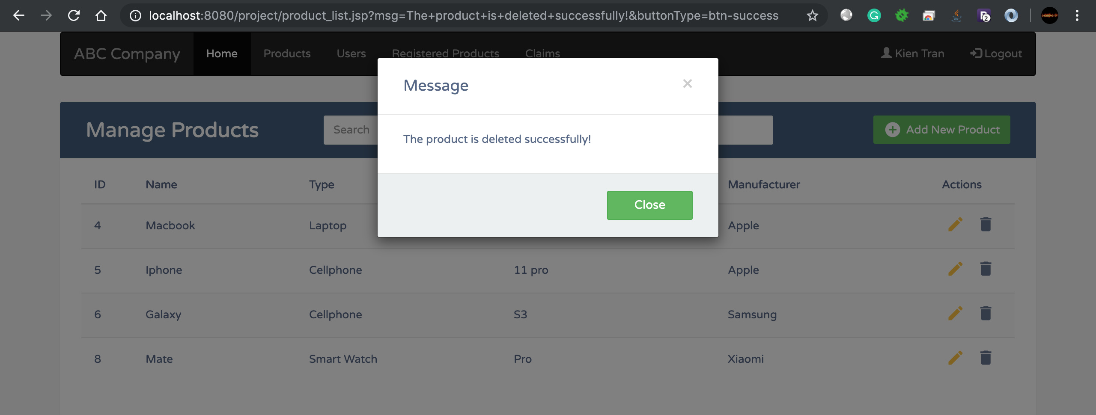

1. Admin can view a list of users and searching on that list

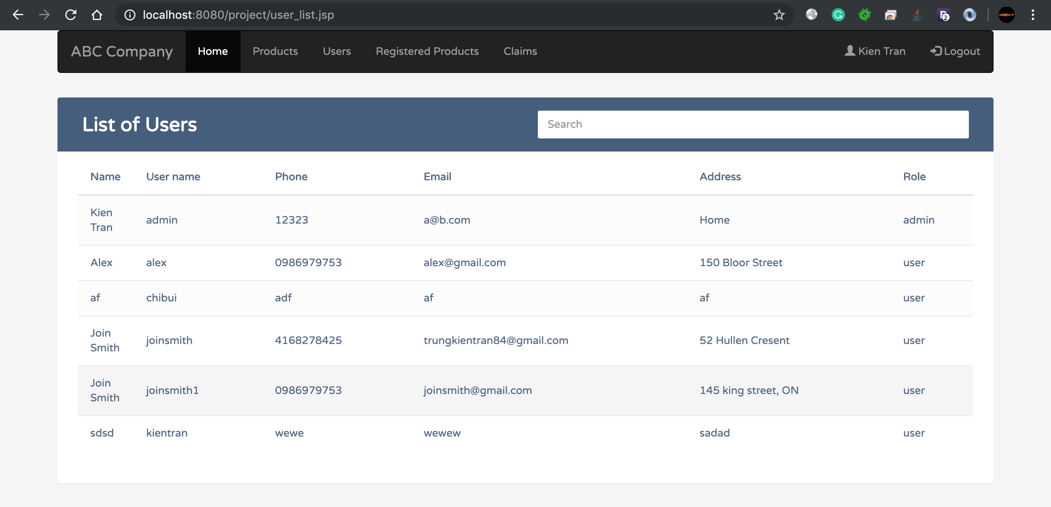

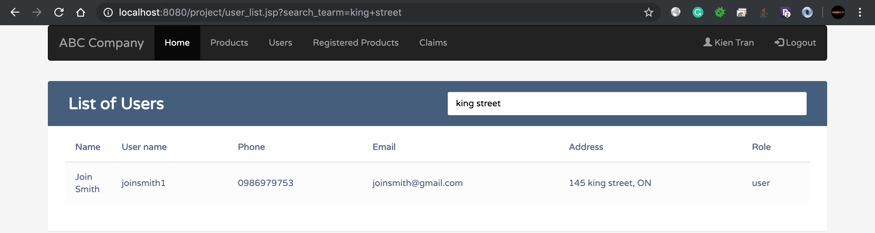

1. Admin can view a list of registered products and search in that list

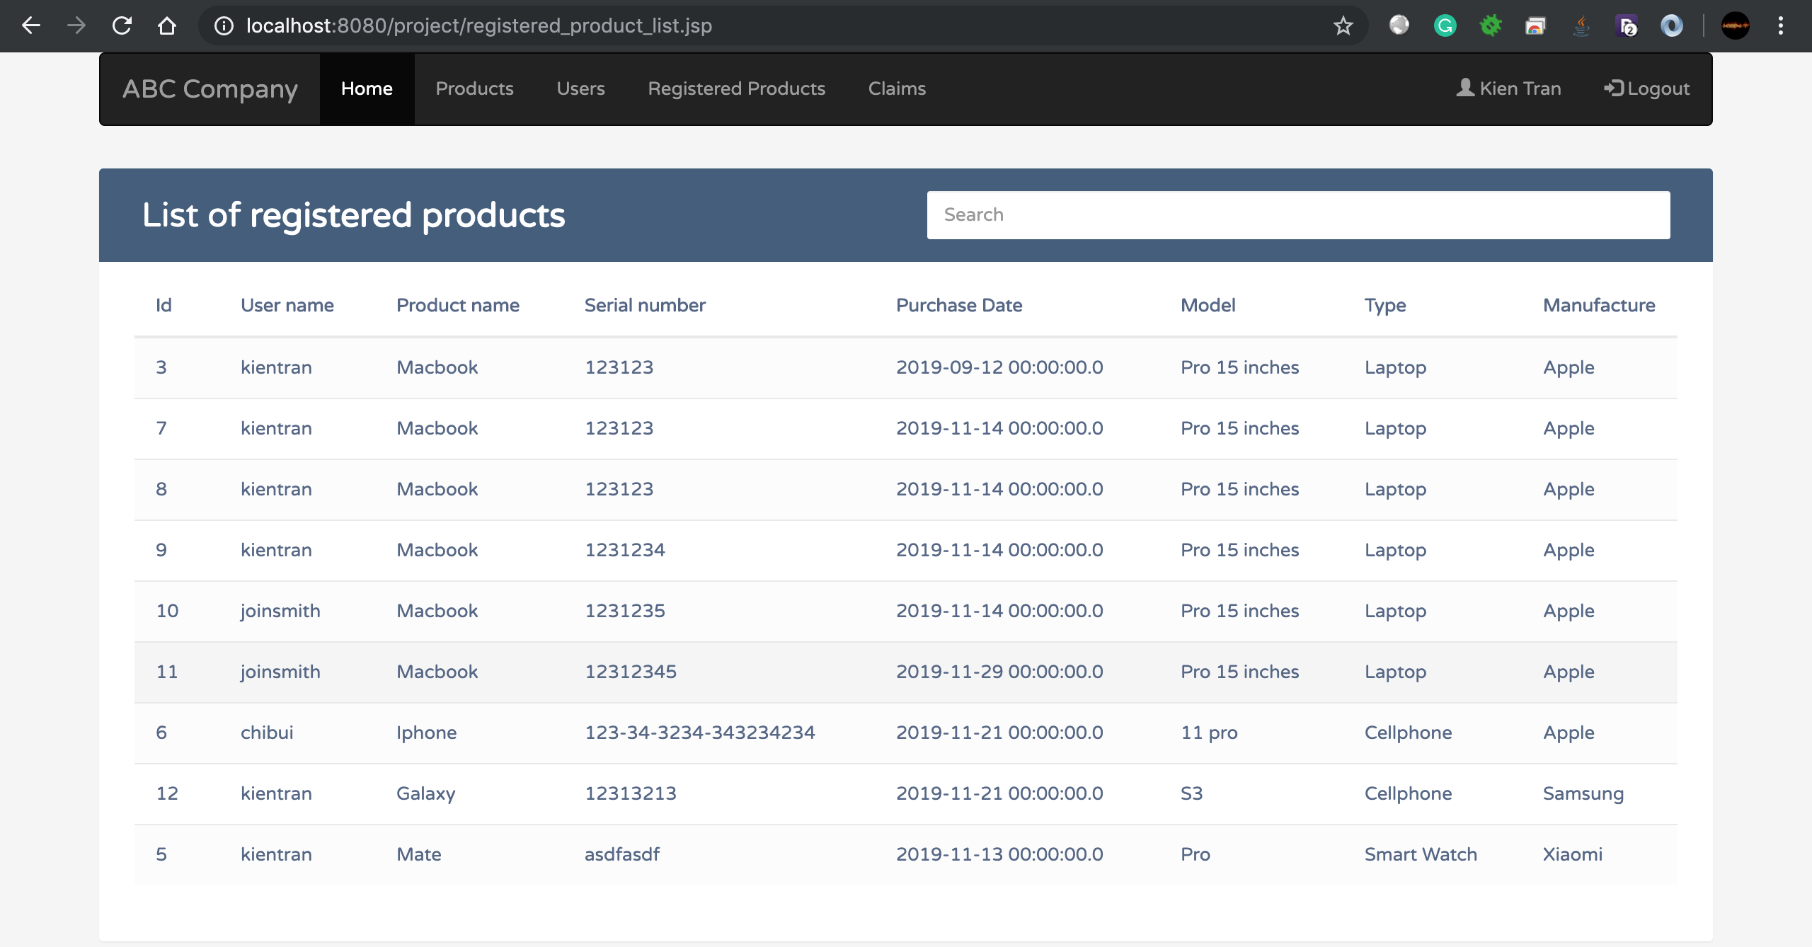

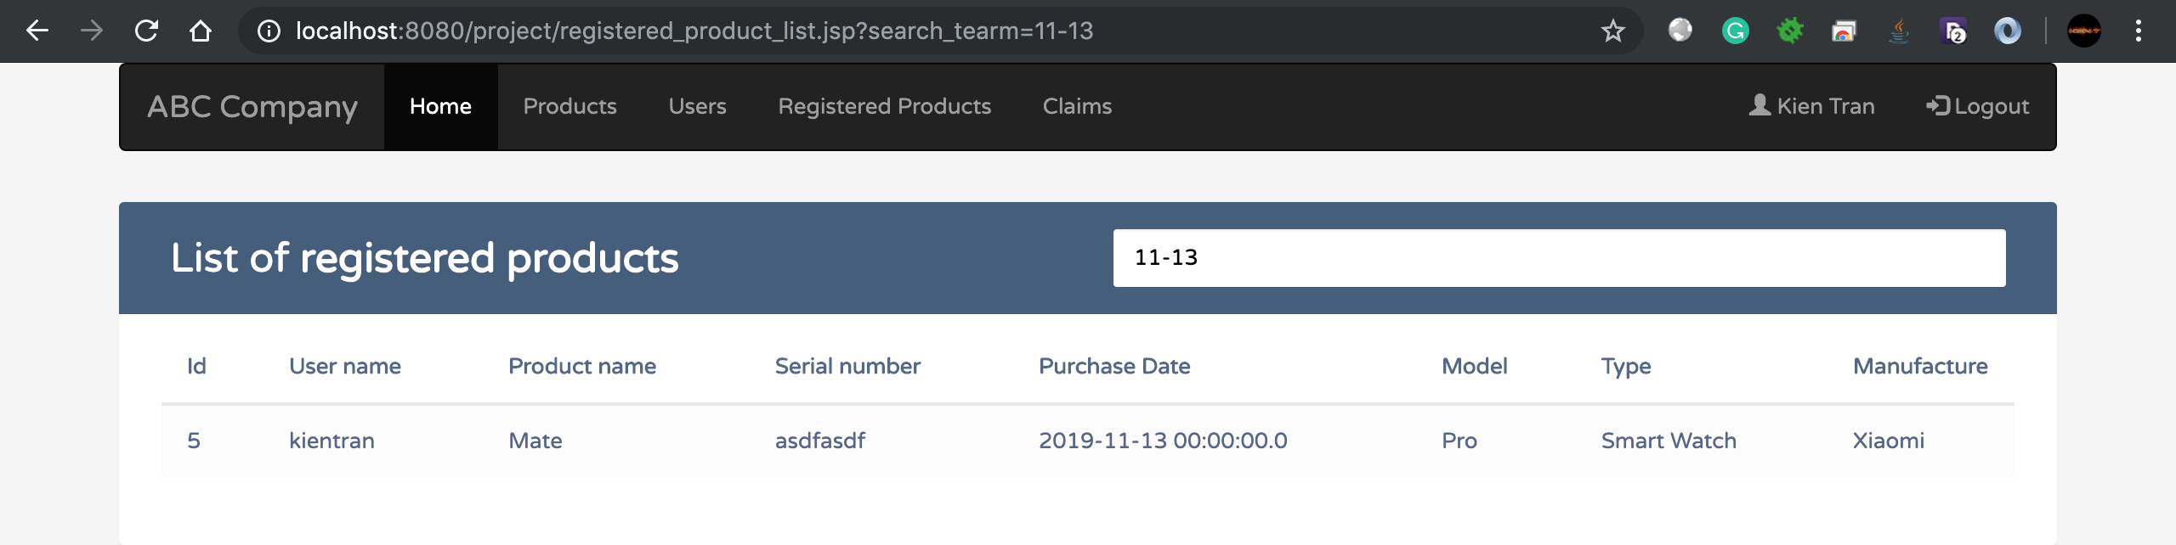

1. Admin can view a list of all claims, searching on the list and approve for waiting approval claims

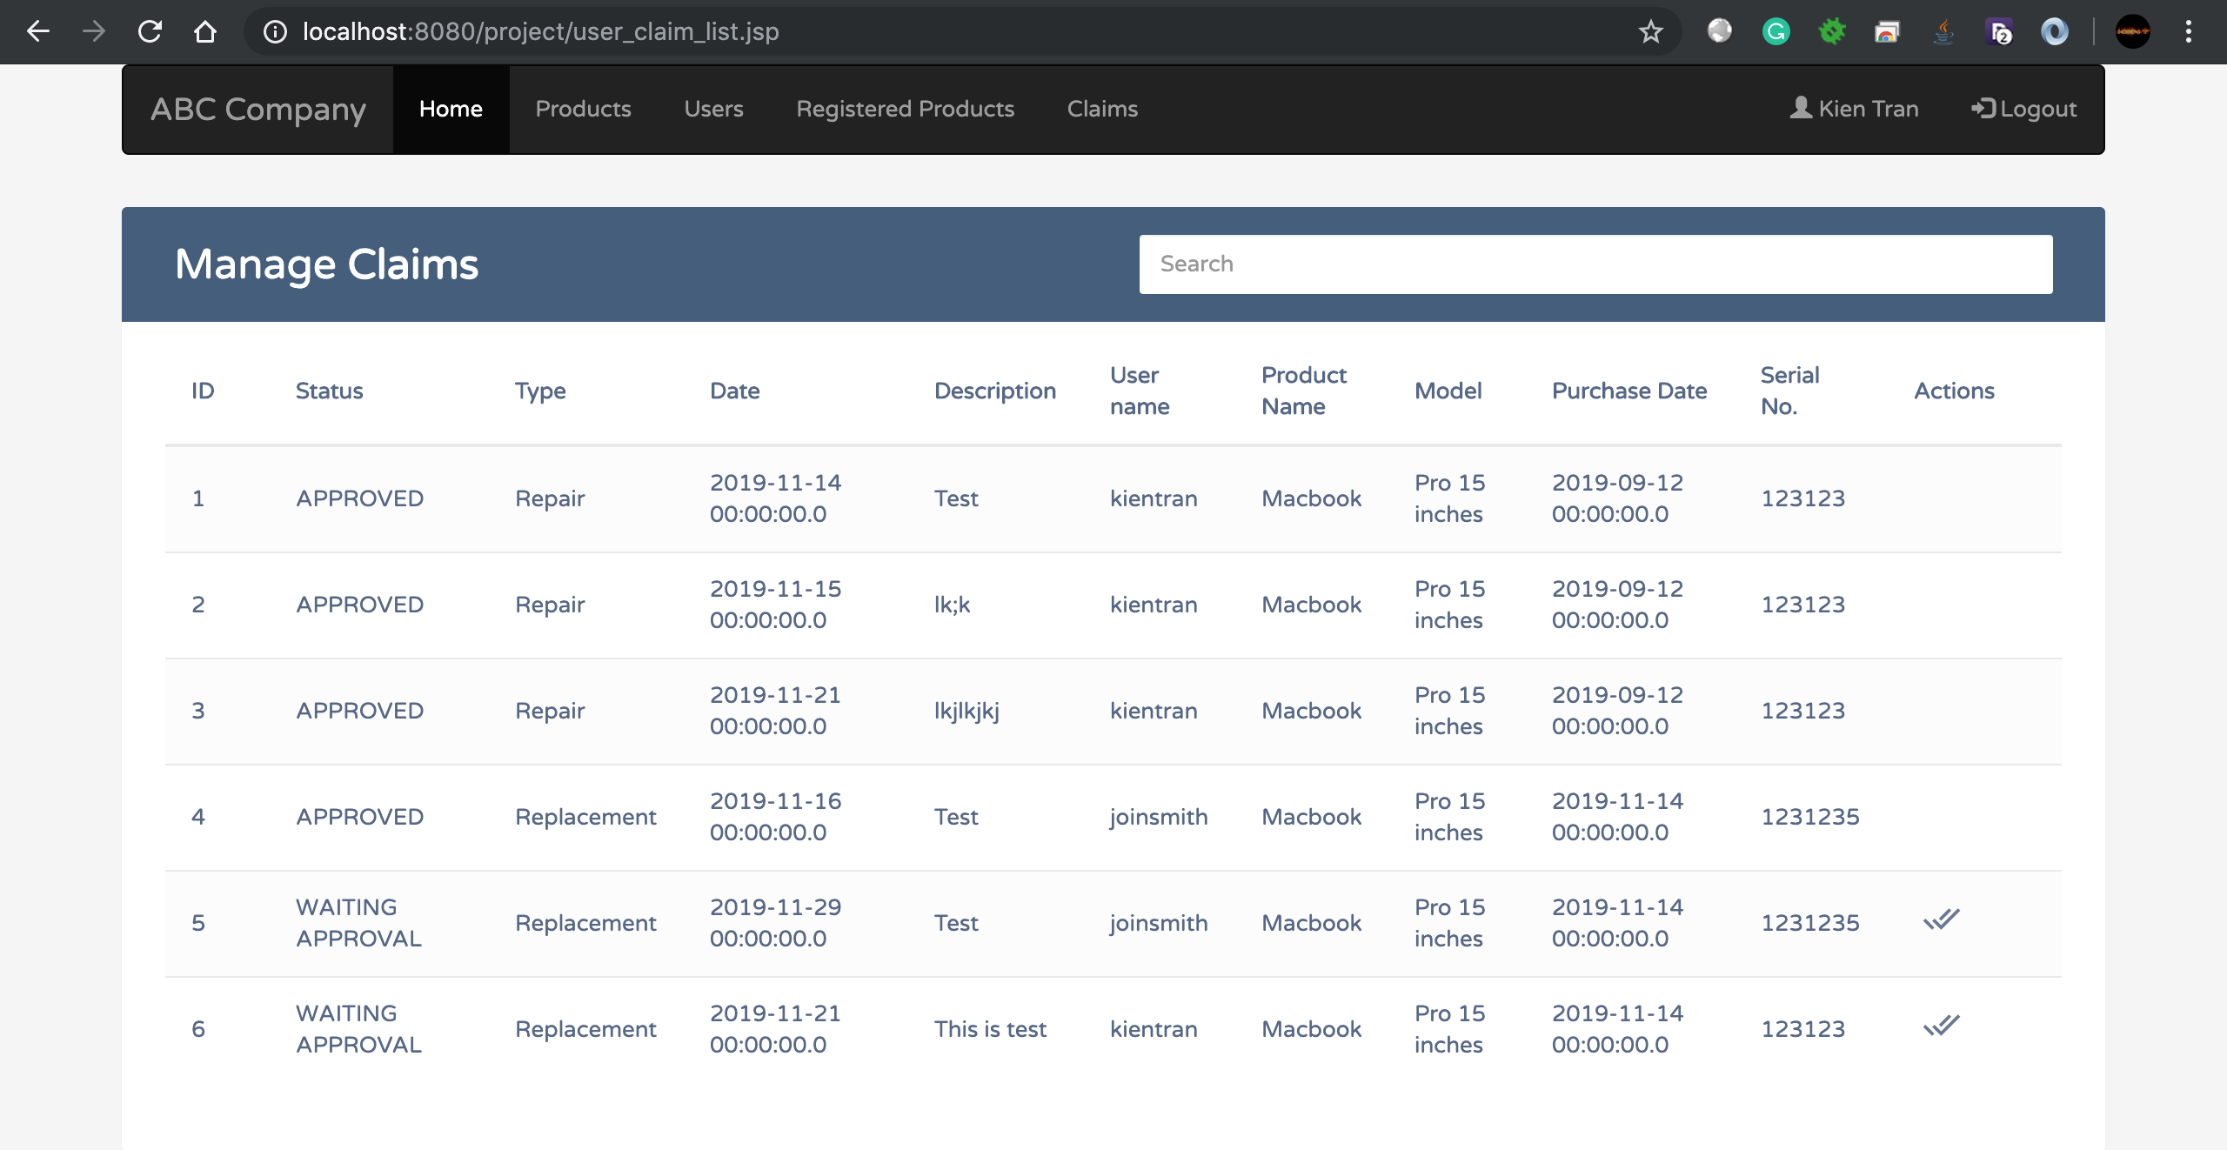

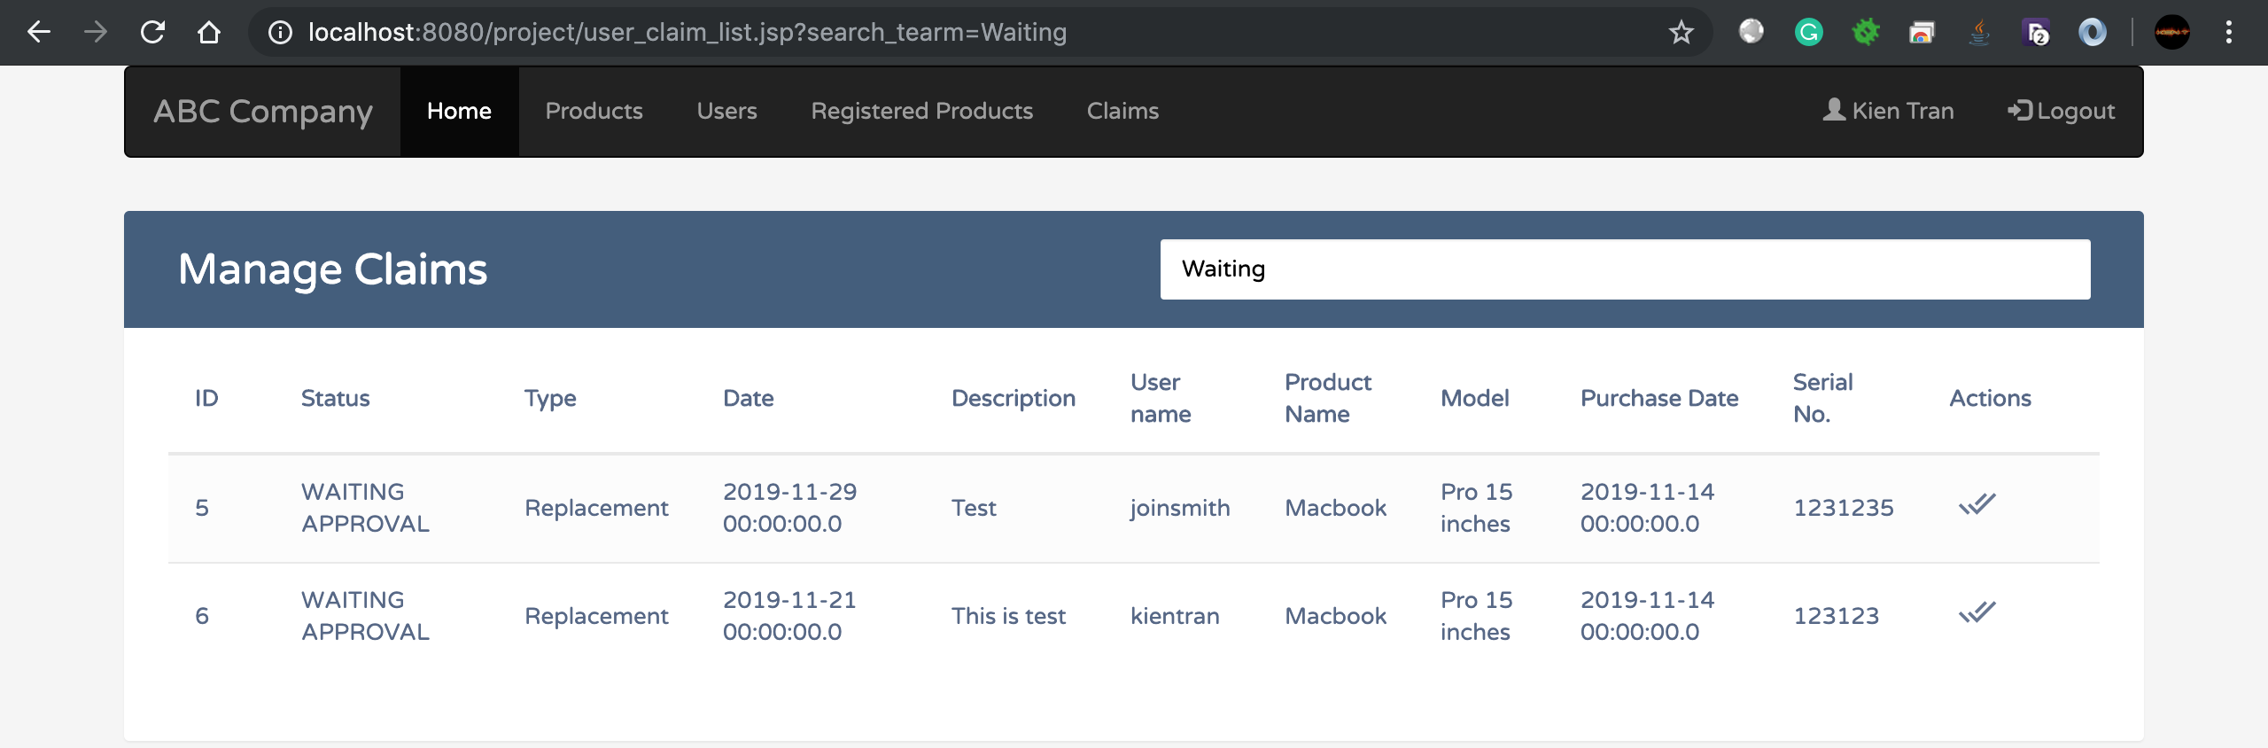

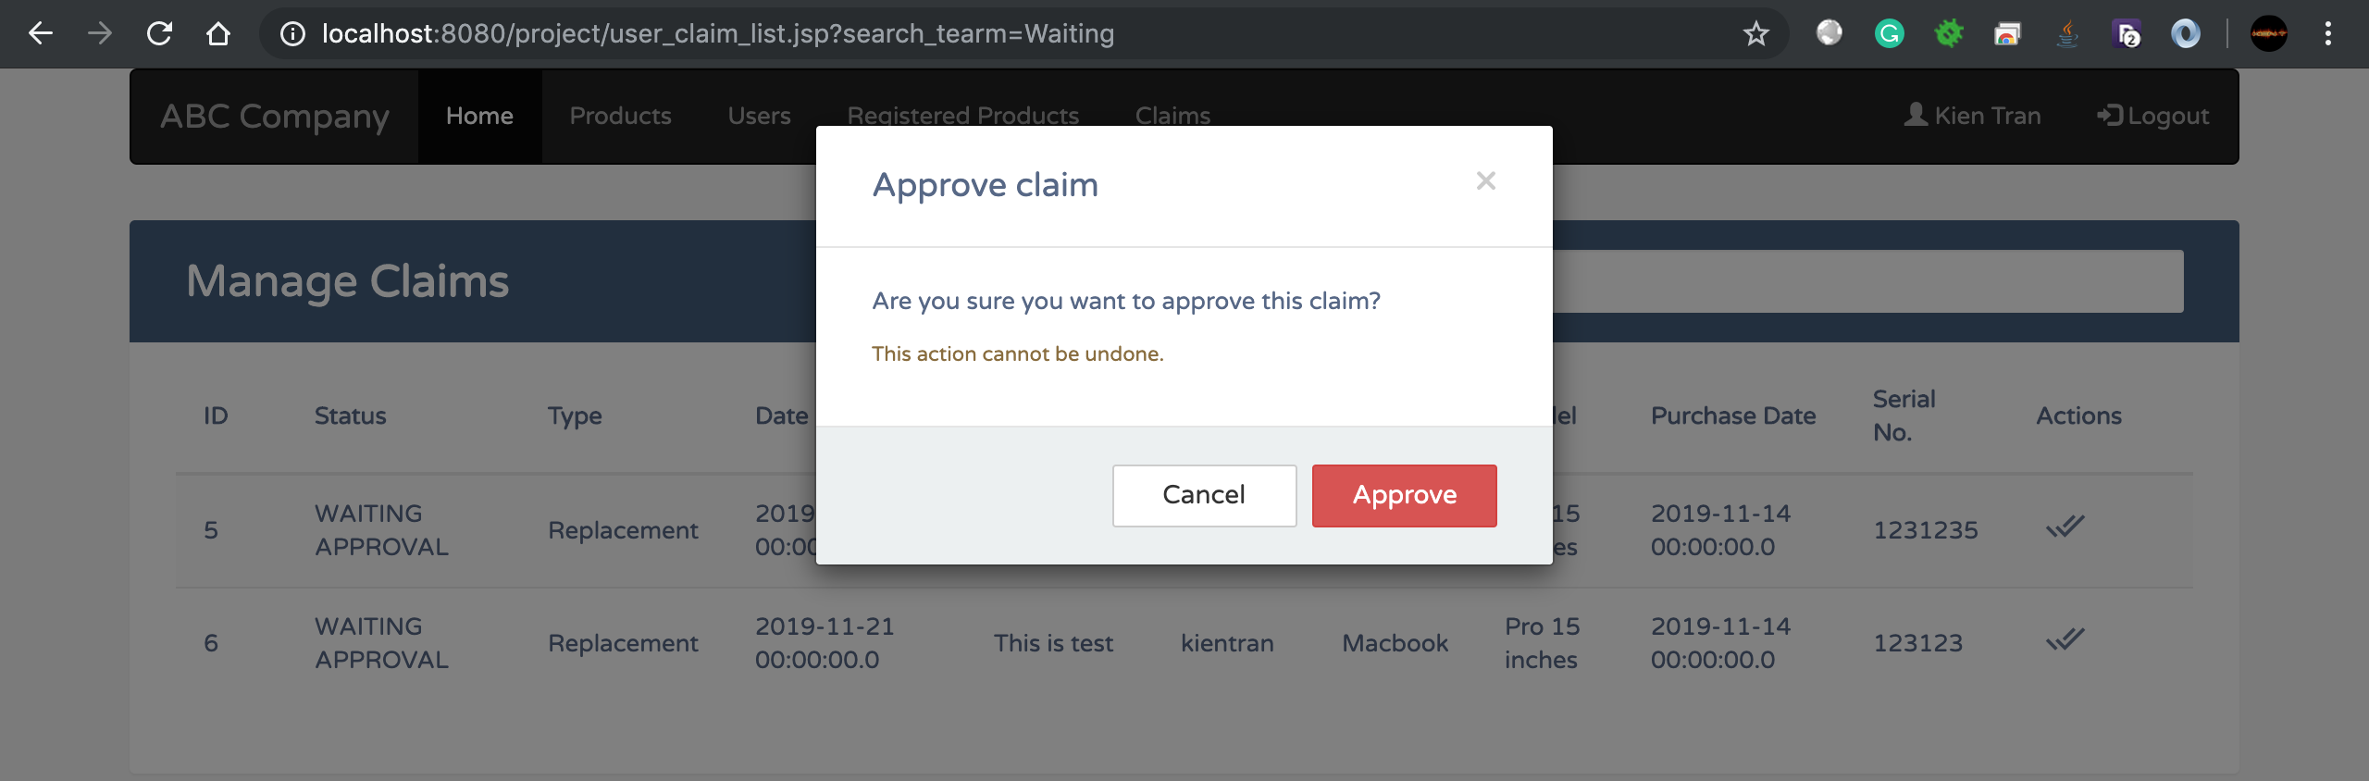

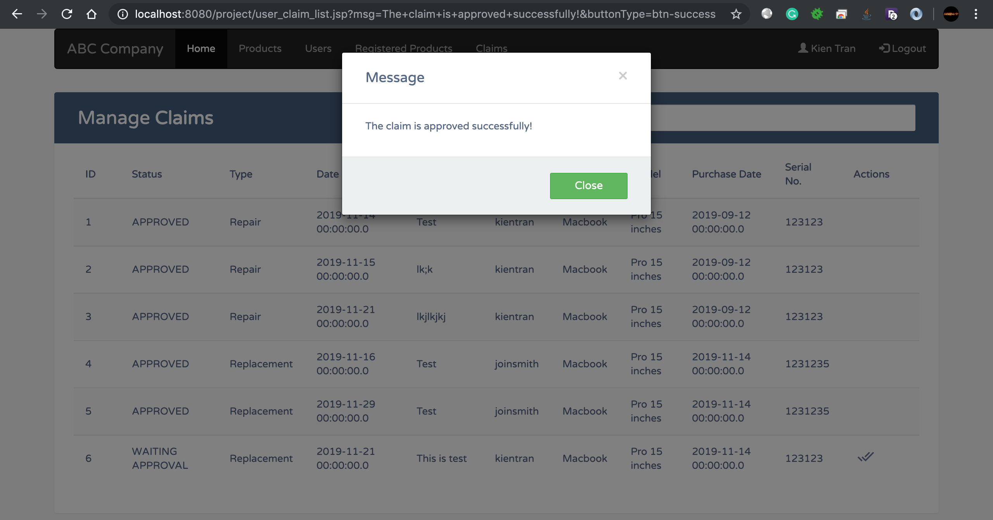

# Section 7: How to Deploy the Web application

(Explain and demonstrate how to deploy the web application—execute it outside the eclipses. *If you have answered the bonus question, you can demonstrate how to deploy the web application into a free webhost!*)

1. Export the project to war file

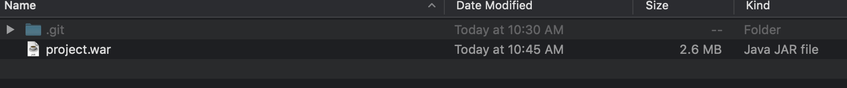

1. Copy war file to tomcat web folder

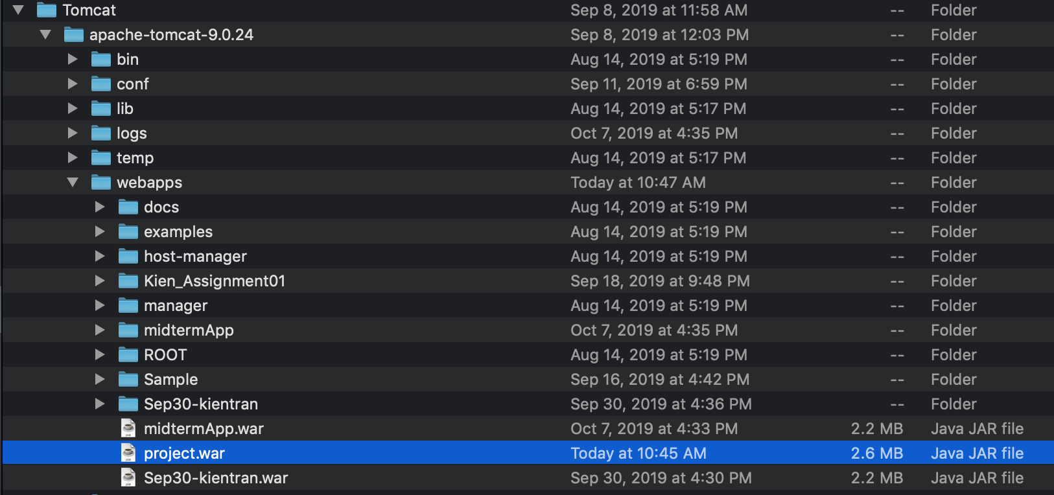

1. Start Tomcat

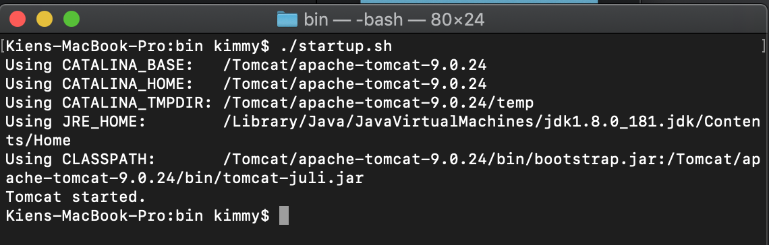

1. Access the webpage

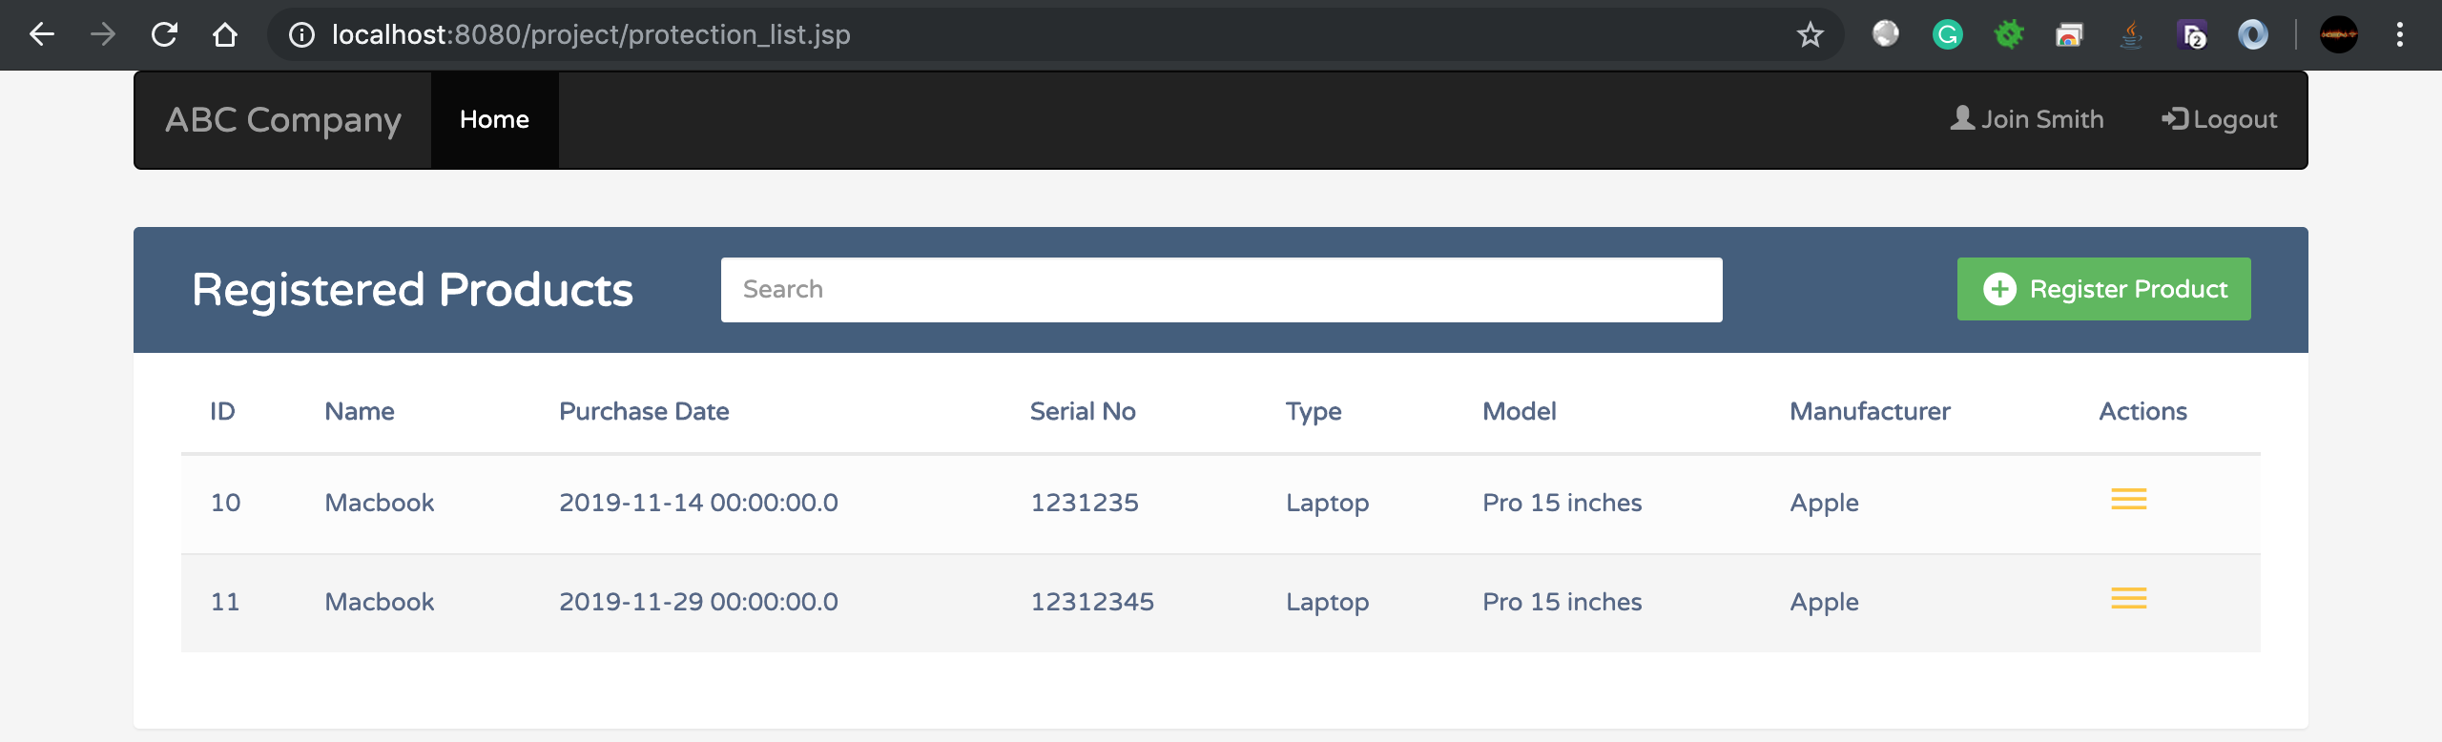

# Section 8: Project Feedback

(How did you manage team working in regards to sharing files/source codes, database files, …?

How do you evaluate your work? How do you evaluate your time management? How do you evaluate your experience in this project in term of team-working, programming skill, …? )

* We used github.com to share code between members
* We first created complete database structure for the project then fill up with dummy data. Finally, we share the sql dump file with each other through github.com
* How do you evaluate your work?
  + Good
* How do you evaluate your time management?
  + Good
* How do you evaluate your time management?
  + Good